
FACULTY OF ENGINEERING & TECHNOLOGY
Department of Computer Engineering 01CE0607 - Software Engineering – Lab Manual

Practical 1
Problem Statement with Purpose, Scope, Literature Review, and Future Scope(16 pt-bold-Times New Roman)

Aim: Identify a relevant problem or project definition. Write a detailed problem statement for the system, along with its Purpose, Scope, Existing system details with a literature review and mention Future scope of the system.

QRCode Pro — Professional QR Code Generator

- Introduction
QRCode Pro is a web-based QR code generation platform built with PHP 8.0+, SQLite, Tailwind CSS, and JavaScript. It supports 24+ QR code types, 62 customization controls, bulk generation (up to 100 codes), an integrated camera scanner, and full export in PNG, SVG, and PDF.

Problem Statement

QR codes are ubiquitous in payments, marketing, and information sharing. However, existing free tools support only 3–5 types, offer minimal customization, lack bulk generation, provide no history or analytics, and require separate apps for scanning. There is a need for a unified, self-hosted platform combining comprehensive generation, deep customization, bulk processing, scanning, and history management.

Purpose of the System

QRCode Pro provides a unified platform for QR code workflows: 24+ QR types (URL, WiFi, vCard, UPI, WhatsApp, social media, etc.), 62 visual customization controls across 9 categories, bulk processing for up to 100 codes, integrated scanning via camera/upload, persistent history with favorites, and Chart.js dashboard analytics. All data stays local with bcrypt security and self-hosted deployment.

Scope of the System

The scope of QRCode Pro includes the following key functionalities:

    - QR Code Generation: 23 type-specific forms supporting URL, WiFi, vCard, UPI, WhatsApp, Email, SMS, Calendar, GPS, Bitcoin, YouTube, Twitter, Instagram, Facebook, LinkedIn, Spotify, Zoom, PDF, Image, MeCard, and App Store links with real-time preview.
    - Customization Engine: 62 controls in 9 sections — color presets, dot style & gradient, background, eye frame, eye dot, logo/watermark, frame & label, shadow, and size/export settings.
    - Export & Management: PNG/SVG/PDF download, print, clipboard copy, bulk ZIP export, searchable history with favorites, CSV export, and dashboard analytics with Chart.js charts.

FACULTY OF ENGINEERING & TECHNOLOGY
Department of Computer Engineering 01CE0607 - Software Engineering – Lab Manual
- Supports 24+ QR types: URL, WiFi, vCard, UPI, WhatsApp, Bitcoin, YouTube, Instagram, Facebook, LinkedIn, Spotify, Zoom, SMS, Email, Phone, Calendar, GPS, MeCard, PDF, Image, App Store.
- 62 customization controls in 9 sections: colors, dot styles, gradients, eye frames, logo overlay, frame & label, shadow effects, and export settings.
- Bulk generation (up to 100 codes from text/CSV), integrated QR scanner (camera + upload), searchable history with favorites, and Chart.js analytics dashboard.

1.3 Limitations

QR images are generated client-side using JavaScript. The server stores only metadata (type, title, content, settings JSON), not the actual images.

Camera scanning requires HTTPS in production. SQLite has limited concurrent writes (mitigated via WAL mode).

Maximum bulk generation is 100 codes per batch. QR codes must be regenerated if browser cache is cleared.

1.4 Existing System and Literature Review

Table:1 Existing System Study
Title | Author | Year | Method | Advantages | Disadvantag es | Tools used | Remark
QR Code Generation using Python | Jain, Singh, Kumar | 2021 | Python qrcode library with PIL for image generation | Simple implementation, open-source, easy integration | No customization options, single QR type only (text/URL) | Python, qrcode, PIL library | Basic text-to-QR only. No visual styling or type variety.
QR Monkey (qrmonkey.com) | QR Monkey Team | 2023 | Web-based generator using JavaScript Canvas API with basic color options | Free, supports ~8 types, logo upload, no account needed | No bulk generation, no history, limited customization, no scanner | JavaScript, HTML5 Canvas API | Popular free tool but lacks depth in customization and management.
QR Code Generator Pro | Egoditor GmbH | 2022 | SaaS platform with freemium model, dynamic QR codes with analytics | Dynamic QR, scan analytics, professional dashboard, enterprise features | Most features are paid, no self-hosting option, data stored on their servers | React.js, Node.js, Cloud infrastructure | Enterprise-grade but not privacy-focused or open-source.
Dynamic QR Code System for Smart Cities | Sharma, Kumar | 2022 | Server-side QR generation with redirect tracking and scan analytics | Scan analytics with geographic data, URL redirect management | Complex server setup required, dependent on server availability | PHP, MySQL, Google Charts | Research-focused implementation for smart city use cases.

FACULTY OF ENGINEERING & TECHNOLOGY

Department of Computer Engineering 01CE0607 - Software Engineering – Lab Manual
GoQR.me REST API | GoQR.me Team | 2023 | Server-side Java REST API for QR code generation in multiple formats | API-first design, supports PNG/SVG/EPS output, developer-friendly | No user interface, no auth system, no customization beyond basic colors | Java, REST API architecture | Developer-focused tool only. No end-user application.
QR Code Styling Library | Nickolay Bliokh | 2023 | Client-side canvas rendering with dot styles, eye frames, gradients, logos | Deep visual customization, 6 dot styles, gradient support, logo overlay | JavaScript library only, no full application or user management | JavaScript, HTML5 Canvas API | Foundation for QRCode Pro’s generation engine.
html5-qrcode Scanner | mebjas (Minhaz) | 2023 | Camera-based QR code decoder using WebRTC with multi-camera support | Fast decode at 10fps, multi-camera switching, file upload support | Decode only, no QR generation capability, requires HTTPS | JavaScript, WebRTC API | Used as QRCode Pro’s scanner module.
Chart.js Analytics Library | Chart.js Team | 2023 | Responsive canvas-based chart rendering with doughnut, bar, line types | Lightweight, responsive, extensive chart types, easy configuration | Client-side only, no server-side rendering or data processing | JavaScript, HTML5 Canvas | Used in QRCode Pro dashboard for analytics visualization.
jsPDF + JSZip Export | jsPDF & JSZip Teams | 2023 | Client-side PDF generation and ZIP archive creation libraries | No server round-trip needed, handles binary data, custom layouts | Memory limits for large files, limited font support in PDF | JavaScript, Canvas API | Used in QRCode Pro for PDF export and bulk ZIP download.
Aadil Parmar(92200103068)

Strategies |  |  | memorability, and | sensitivity |  | QR code | backfire.
 |  |  | QR code managers. | accounts model |  | policy | classificatio
 |  |  |  |  |  | frameworks | n + long
 |  |  |  |  |  |  | QR codes +
 |  |  |  |  |  |  | QR code
 |  |  |  |  |  |  | managers +
 |  |  |  |  |  |  | 2FA.
QR codes – | Gary C. | 1996 | Analytical security study: | Clear | No controlled user | RFC 1244 | QR codes
Strength and | Kessler |  | reviews real QR code | explanation of | experiments,Based | guidelines, | are
weakness |  |  | practices, explains attack | QR code | on older Unix | encoding complexity | inherently
 |  |  | techniques. | encoding complexity, Covers | limits (8 chars) | calculations, | weak
 |  |  |  | real attack |  | brute-force | because
 |  |  |  | vectors |  | probability | humans
 |  |  |  | (spoofing, |  | tables | choose
 |  |  |  | replay, social |  | (Schneier) | predictable
 |  |  |  | engineering) |  |  | secrets.
 |  |  |  |  |  |  | Even long
 |  |  |  |  |  |  | QR codes
 |  |  |  |  |  |  | give low
 |  |  |  |  |  |  | encoding complexity
 |  |  |  |  |  |  | unless
 |  |  |  |  |  |  | character
 |  |  |  |  |  |  | diversity is
 |  |  |  |  |  |  | high

Future Scope
The evolution of QRCode Pro will advance with emerging technologies and growing user demands. The future scope includes:

AI-Powered QR Design

  - AI will analyze QR code readability and warn users before downloading codes that may be difficult to scan.
  - AI-based color extraction from uploaded images to create matching QR color schemes automatically.
  - Machine learning models to predict optimal error correction levels based on intended use case.

Dynamic QR Codes with Scan Analytics

  - Dynamic QR Codes with Scan Analytics: Implement redirect-based dynamic QR codes where destination URLs can be changed after printing. Track scan counts, geographic locations, device types.
  - Dashboard analytics with heatmaps showing scan patterns, geographic distribution, and device breakdown.
  - Scheduled QR code expiry and automatic URL rotation for marketing campaigns.

Progressive Web App and Mobile: Convert QRCode Pro into a PWA with offline scanning capabilities.

  - Develop native Android and iOS apps using React Native for enhanced camera scanning performance.
  - Push notifications for scan alerts and QR code expiry reminders.
  - Offline-capable PWA mode for scanning QR codes without internet connection.

API Marketplace: Develop a full REST API with API key authentication for developers.

  - Create WordPress, Shopify, and WooCommerce plugins for seamless e-commerce integration.
  - Webhook support to notify external systems when QR codes are scanned.
  - Automated QR code health monitoring with alerts for broken destination URLs.

Enterprise Features: Team workspaces with role-based access control for collaborative QR management.

White-label support allowing businesses to deploy QRCode Pro under their own branding. SAML/SSO integration for enterprise single sign-on authentication.

2. Conclusion
We identified the problem of fragmented QR code tools and defined a comprehensive solution — QRCode Pro. Through literature review, we analyzed existing systems and identified gaps that QRCode Pro addresses with 24+ QR types, 62 customization controls, bulk generation, integrated scanning, and full history management.

References:-
https://github.com/nickolay-bliokh/qr-code-styling — QR Code Styling Library (foundation for QR engine)
https://www.qrmonkey.com — QR Monkey (existing system analyzed in literature review)www.cs.ru.nl/bachelors-theses/2010/Martin_Devillers 0437999 Analyzing_password_strength.pdf?
https://goqr.me — GoQR.me API (existing system analyzed for comparison)
https://davidshimjs.github.io/qrcodejs/ — QRCode.js Library (used for basic QR previews)www.researchgate.net/publication/



Practical-2
Planning and Scheduling, for System Development
Aim: Perform Project Planning & scheduling by define and design effective policies, methodologies, and strategies to achieve the objectives of the selected system (Mention your selected System). Create a schedule by assigning tasks, allocating resources, and estimating budgets and time frames.

Project Planning and Scheduling involve defining project objectives, breaking down development tasks, allocating resources, and estimating timelines to ensure successful delivery. For the QRCode Pro, planning includes defining security requirements, designing the analyzer architecture, implementing QR generation logic, integrating attack-detection rules (dictionary, pattern, encoding complexity), and testing usability.

Scheduling assigns milestones for core modules such as QR code generation, real-time feedback, reporting, and optional API integration. A clear timeline helps track progress, reduce security risks, and ensure efficient use of development resources.

Users and organizations often struggle with weak, predictable QR codes, leading to security breaches. The QRCode Pro automates QR code generation using encoding complexity checks, type detection, and rule-based validation. The system will provide real-time feedback, crack-time estimation, weak-QR code alerts, and improvement suggestions—resulting in stronger credentials, better user awareness, and improved overall data security posture.

Project Planning and Objectives
Effective project planning defines goals, tasks, resources, and schedules, ensuring a smooth development process. The QRCode Pro project focuses on detecting basic QR codes, providing real-time strength feedback, and improving user security awareness through encoding complexity analysis and type detection. The system aims to offer a user-friendly interface along with secure and accurate evaluation of QR code data. The planned development steps ensure completion within the designated timeline while effectively meeting data security and user requirements.

Choice of Process Model: Waterfall Model
The Waterfall Model follows a simple step-by-step development process where each phase is completed before moving to the next. This approach fits the QRCode Pro project because the main requirements—like QR code quality checking, QR encoding, and type detection—are clearly defined from the start and are unlikely to change much. Using Waterfall helps keep the development organized, ensures proper testing at each stage, and leads to a stable and secure final system.



Reason for choosing waterfall model

Simple Project Structure: The QRCode Pro follows a straightforward flow, making Waterfall easy to manage and understand.

Easy Progress Tracking: Each phase has clear completion goals, allowing better monitoring of development progress.

Strong Focus on Security Design: Early planning helps finalize QR code rules and security logic before coding begins.

Suitable for Small Team Development: Waterfall works well when development is handled by a small or individual team.

Stable Core Functionality: QR code analysis logic does not change frequently, making sequential development practical.

Quality Control: Each stage is reviewed before moving forward, reducing chances of major errors later.

Predictable Timeline: Fixed phases make it easier to estimate delivery time.

Phases of the Waterfall Model Applied to QRCode Pro Requirement Analysis
In this phase, the security needs and system goals are clearly identified. Input is collected to understand how QR codes should be evaluated and how feedback should be presented to users.
Key Requirements for QRCode Pro:
QR code input and validation
Strength scoring using encoding complexity and rules
Detection of weak patterns and common QR codes Real-time feedback and improvement suggestions Crack-time estimation
Secure handling of QR code data and report generation
Deliverable: Requirement specification document for the QRCode Pro.


System Design

This phase converts requirements into a technical blueprint for development. The system architecture, logic flow, and database structure are planned.

Design Steps:
- Define database structure for storing analysis results and logs (if required).
- Create UML diagrams such as use case, activity, dataflow, and class diagrams to represent system behavior.
- Design the QR code generation logic (QR encoding + pattern rules).
- Develop UI mockups for easy user interaction.
Deliverable: Design documents, database schema, system flow diagrams, and UI layouts.

Implementation

The actual development of the QRCode Pro based on the design documents takes place in this phase. Developers focus on building individual components and integrating them progressively into a complete system.

Development Steps:

  - Build the QR Data Input Module to securely accept user QR codes for analysis.
  - Create the QR Code Generation Engine to calculate QR code quality using factors such as length, character variety, encoding complexity, and common-type detection.
  - Develop the Rule-Based Analyzer Module to identify basic QR codes (invalid QR data, duplicate entries, sequences, etc.).
  - Implement the History & Export Module to provide real-time suggestions for improving basic QR codes.
  - Add the Reporting Module to display QR code previews, vulnerability types, and improvement tips.

Deliverable: Functional system modules for the QRCode Pro.


Integration and Testing

  - After individual modules are completed, they are integrated and thoroughly tested to ensure smooth interaction.

  - Testing Includes:
    - Unit Testing: Verifying each module (QR data input, analyzer, feedback system) independently.
    - Integration Testing: Ensuring proper data flow between evaluation and feedback modules.
    - System Testing: Validating the complete QRCode Pro for accuracy, performance, and user experience.
  - Deliverable: A fully integrated and tested QRCode Pro.

Deployment and Maintenance

In this phase, the QRCode Pro is deployed on the target server or cloud environment, followed by user onboarding.

Deployment Steps:

- Deploy the application on hosting infrastructure (local server or cloud).
- Perform basic user training or documentation sharing.
- Provide ongoing maintenance to fix bugs, update rules, and improve detection logic.

Deliverable: Fully operational QRCode Pro with post-deployment support.

Project Scheduling
Scheduling is a vital part of project planning that organizes tasks, resources, and timelines to ensure timely completion. It involves dividing the project into phases, defining dependencies, estimating development duration, and assigning resources accordingly.
For the QRCode Pro, scheduling ensures systematic development while maintaining quality, security, and performance constraints.

Purpose of Scheduling

- Organize Tasks: Establishes a structured roadmap for completing all required development activities of the QRCode Pro.

- Define Priorities: Identifies task dependencies so critical components like the QR code generation engine are developed before testing begins.

- Allocate Resources: Ensures developers, security researchers, and testing tools are available for each development phase.

- Monitor Progress: Tracks project progress against planned milestones and deadlines.
- Avoid Delays: Reduces the risk of project overruns through proactive planning and risk management.

Key Elements of Scheduling in QRCode Pro

- Task Identification:
Identify specific tasks required to develop and deploy the system, such as requirement analysis, algorithm design, module implementation, testing, and deployment.

Task Sequencing and Dependencies:
Some tasks depend on others to be completed first. For example:

- The QR Code Generation Engine depends on rule definition and algorithm design.
- The Feedback Module depends on the output of the evaluation engine.
- Testing can only begin after all modules are implemented.

Estimating Task Duration:
Estimate the time required for each activity based on technical complexity, algorithm research, and available team members.

Resource Allocation:
Assign responsibilities based on expertise. Example:
- The Backend Developer designs and implements the evaluation logic during weeks 1–3.
- The Security Analyst defines QR code quality rules and testing datasets.
- QA Engineers conduct testing during weeks 8–9.

Milestones:
Define key checkpoints such as completion of requirement analysis, implementation of the evaluation engine, testing completion, and final deployment.

Overview of the Schedule

The schedule spans 10 weeks and consists of the following phases:

Table :1 Schedule Overview

Task Duration Description
Requirement Analysis 1 week Define functional and non-functional requirements.
System Design 1 weeks Design system architecture, evaluation logic, and UI mockups.
QR Data Input Module 1 week Develop secure QR data input handling.
QR Code Generation Engine 3 weeks Implement QR encoding, type detection, and
scoring logic.

History & Export Module
1 week Generate improvement suggestions dynamically.

Reporting Module 1 week Display QR code preview, weaknesses, and analytics. Testing 1 week Conduct unit, integration, and system testing.
Deployment & Documentation 1 week Deploy system and prepare user documentation.

Project scheduling Using Gantt Chart

A Gantt Chart is a visual scheduling tool that shows tasks along a timeline, their durations, dependencies, and milestones. Below is an illustration of how the QR Code Quality Analysis App tasks are scheduled over 10 weeks.

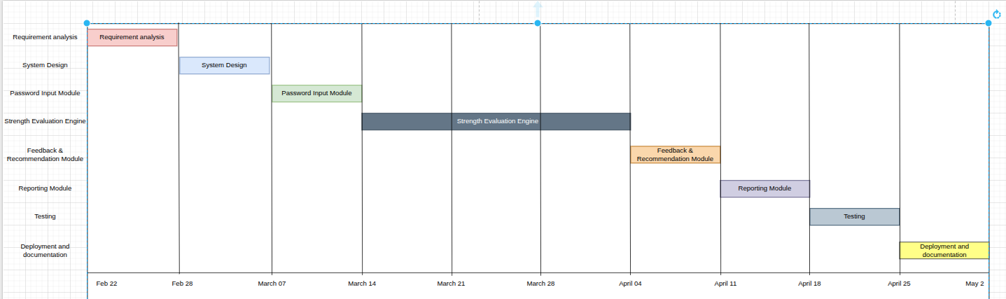
Figure 1: Gantt chart

A well-structured schedule ensures that the QRCode Pro development progresses systematically while maximizing efficiency, meeting deadlines, and delivering a high-quality security tool. By visualizing timelines and resource usage through tools like Gantt charts, the project achieves its objectives in a planned and controlled manner.

Resource Allocation

Efficient resource allocation ensures task ownership and smooth execution:


- Project Manager: Oversees planning, timeline tracking, and overall deliverables.
- System Analyst: Handles requirement gathering and security documentation.
- Security Analyst: Designs QR code rules, threat models, and strength metrics.
- Front-End Developer: Builds an intuitive interface for QR data input and feedback visualization.
- Back-End Developer: Implements the QR code generation engine, APIs, and business logic.
- QA Engineer: Performs comprehensive testing for accuracy, performance, and edge cases.

Risks and Mitigation

Every software project carries risks that may affect progress. For the QRCode Pro, common risks include algorithm inaccuracies, scope creep, and limited security datasets. These are mitigated by:
- Defining clear requirements early to avoid unnecessary feature expansion.
- Validating strength algorithms using known weak-pattern datasets.
- Cross-training team members to handle temporary resource gaps.
- Performing regular code reviews and testing cycles to resolve technical issues early.

Deliverables

Key deliverables for the QRCode Pro project include:

- Requirements Document: Detailed functional and non-functional security requirements.
- System Design Artifacts: Architecture diagrams, flowcharts, and evaluation logic models.
- Functional QRCode Pro: Fully tested and deployed application.
- User Documentation: Guides explaining QR code outputs and improvement suggestions.
- Testing Reports: Recorded results of unit, integration, and system testing.

This structured planning and scheduling approach ensures the QRCode Pro is developed with precision, following the principles of the Waterfall Model. The Gantt chart clarifies timelines, while proactive risk mitigation supports successful delivery of a reliable security solution.



Practical-3
Cost and Effort Estimation for Software Development
Aim: Perform a cost and effort estimation for the selected system by understanding the scope of the software to be developed.

Cost estimation and effort analysis are essential for planning and managing software projects, helping predict the required resources, time, and budget. Function Point Analysis (FPA) is a widely used method to estimate software size, effort, and cost. It measures the functionality delivered to the user, independent of programming languages or technologies. Function points are calculated based on five key components: External Inputs (EI), External Outputs (EO), External Inquiries (EQ), Internal Logical Files (ILF), and External Interface Files (EIF). Each component is assigned a weight based on its complexity (Low, Medium, High), and these are summed up to determine the system's size. This quantitative measure is then used with productivity rates or cost factors to estimate the total effort (in person-hours) and cost of the project, ensuring accurate and standardized planning.

Cost and Effort Estimation
To estimate the cost and effort for developing a QRCode Pro using Function Point Analysis (FPA), the following steps can be utilize.

3.1 Understand the Scope of the System

A QRCode Pro typically includes the following modules:

QR Data Input Module: Securely accepts user QR codes for analysis.
QR Code Generation Engine: Calculates QR code quality based on length, complexity, encoding complexity, and type detection.
QR Scanner Module: Identifies common issues such as invalid QR data, sequences, or duplicate entries.
QR Preview & Export Module: Provides real-time recommendations to improve QR code quality.
Authentication (Optional): Login/logout functionality for users if QR code history or profiles are maintained.



3.2.Identify and Classify Function Types

Function Point Analysis (FPA) for the QRCode Pro involves classifying system components into five elements:
- External Inputs (EI): User-entered QR codes and optional configuration settings.
- External Outputs (EO): QR code QR code preview, vulnerability indicators, and improvement suggestions.
- External Inquiries (EQ): User-triggered requests such as “Check Strength” or “View QR code Report.”
- Internal Logical Files (ILF): Stored rule sets, strength metrics, pattern libraries, and (if enabled) user history.
- External Interface Files (EIF): External datasets such as breach-pattern libraries or common- QR code lists used for validation.

Table 3.1: Functionality breakdown

Functionality | Type | Complexity | Count
1 | QR Generation Forms (23 types with type-specific inputs) | EI | High
2 | User Registration (username, email, password, name) | EI | Average
3 | User Login (username/email + password authentication) | EI | Low
4 | 62 Customization Controls (colors, dots, gradients, logo, frame, shadow) | EI | High
5 | Contact Form (name, email, subject, message) | EI | Average
6 | QR Code Preview (real-time canvas rendering via qr-code-styling) | EO | High
7 | QR Export (PNG with compositing, SVG, PDF via jsPDF) | EO | High
8 | Dashboard Analytics (Chart.js doughnut + bar charts) | EO | Average
9 | History Grid (paginated, searchable, filterable QR codes) | EQ | Average

Table 3.2: Assigning weight for functions

Type | Low | Medium | High
EI | 3 | 4 | 6
EO | 4 | 5 | 7
EQ | 3 | 4 | 6
ILF | 7 | 10 | 15
EIF | 5 | 7 | 10

Calculating Unadjusted Function Points (UFP):


Using the counts and weights above listed in table 3.1 and 3.2. UFP=∑ (Function Count × Weight)

Table 3.3: Function point calculation

Type | Complexity | Count | Weight | Total FP
EI | Low | 2 | 3 | (count*Weight)  6
EI | Medium | 3 | 4 | 12
EQ | Medium | 2 | 4 | 8
EO | Medium | 3 | 5 | 15
ILF | Low | 1 | 7 | 7
ILF | Medium | 2 | 10 | 20  =68

  - Adjust for Complexity Factors

The Value Adjustment Factor (VAF) is applied to the Unadjusted Function Points (UFP) to account for specific technical and operational characteristics of the QRCode Pro. It is derived from 14 General System Characteristics (GSCs), each rated from 0 to 5:

- 0 = No influence on the system.
- 5 = Strong influence on the system.

The formula for calculating the VAF is:

VAF=0.65+(TDI×0.01)

Where TDI (Total Degree of Influence) is the sum of all GSC ratings.

Adjusted Function Points (AFP):
AFP=UFP×VAF



Table 3.4: General System Characteristics for LMS and ratings

No | Characteristic | Description | Rating
1 | Data Communications | 4 | REST API, CDN integrations, AJAX calls for QR generation
2 | Distributed Data Processing | 2 | Single-server SQLite, client-side QR rendering
3 | Performance | 4 | Real-time preview (160ms debounce), instant scanning at 10fps
4 | Heavily Used Configuration | 5 | 62 customization controls across 9 accordion sections
5 | Transaction Rate | 3 | QR save, bulk generate (100 codes), scan operations
6 | Online Data Entry | 5 | 23 type-specific forms, 62 controls, bulk input, CSV upload
7 | End-User Efficiency | 5 | Live preview, color presets, drag-drop, dark mode
8 | Online Update | 4 | Profile update, favorites, delete, password change
9 | Complex Processing | 4 | QR encoding (23 formats), canvas compositing, gradient math
10 | Reusability | 3 | Shared functions.php, reusable header/footer, CSS variables
11 | Installation Ease | 4 | Zero-config SQLite, auto-init schema, .htaccess routing
12 | Operational Ease | 4 | Flash messages, intuitive UI, dark mode, mobile bottom nav
13 | Multiple Sites | 3 | Works on Apache (subdir) and PHP built-in server (root)
14 | Facilitate Change | 4 | Modular PHP includes, CSS variables, configurable base path

- TDI (Total Degree of Influence): TDI = 3+2+4+3+4+5+4+4+4+3+4+4+3+3 = 49
- VAF:

VAF =0.65+ (TDI×0.01)

VAF =0.65+ (49×0.01) = 0.65+0.49 = 1.14

AFP

AFP = UFP * VAF

= 68 * 1.14

= 77.52 ≈ 78

Effort Estimation


Effort is estimated based on AFP and the productivity rate. The productivity rate in the context of Function Point Analysis (FPA) refers to the number of Function Points (FPs) that a development team can complete in one Person-Month (i.e., the amount of work one person can complete in a month).

It is an empirical measure based on:

- Team skill level
- Technology used
- Development environment
- Pat project data

Typical Productivity Rates
  - Simple systems: 25–30 FP/Person-Month
  - Moderately complex systems: 15–20 FP/Person-Month
  - Highly complex systems: 7–10 FP/Person-Month

Effort (Person-Months) = AFP / Productivity Rate
For the QRCode Pro, a Productivity Rate of 20 FP / Person-Month is assumed based on:

- Moderately experienced team
- Standard development tools
- Moderate algorithmic complexity

Effort (Person-Months) = AFP / Productivity Rate Approximately, 78 / 20 ≈ 4 Person-Months

Cost Estimation To estimate cost:
Assumed Developer Monthly Cost = 30,000 Rs

Cost Formula:
Cost = Effort × Monthly Cost Cost = 4 × 30,000
Total Cost = 120,000 Rs

(Note: Cost and effort values are approximate and based on assumed parameters.)

Practical 4


Software Requirement Specification (SRS) Development for the Selected System

Aim: Perform a requirement analysis and develop a Software Requirement Specification (SRS) sheet for the selected system. The SRS should include the following sections:

- Functionality: Describe what the software is supposed to do.
- External Interfaces: Explain how the software interacts with people, the system’s hardware, other hardware, and other software.
- Performance: Outline the expected speed, availability, response time, recovery time, and other performance-related characteristics of the software functions.
- Attributes: Design considerations related to portability, correctness, maintainability, security, and other relevant attributes.
- Design Constraints: Specify any design constraints imposed on the implementation, such as required standards, implementation languages, database integrity policies.

Software Requirement Specification (SRS)
A Software Requirement Specification (SRS) is a structured document that defines the functionalities, constraints, and requirements of a software system. It serves as a foundation for development, testing, and stakeholder communication.

Overview
A QRCode Pro is a security-focused software solution designed to evaluate and improve the strength of user QR codes. It replaces guesswork and weak QR code tools with a structured, intelligent analysis system that assesses QR code complexity, detects vulnerabilities, and provides actionable feedback.

The system enhances security awareness by helping users create better QR codes, reducing the risk of unauthorized access and Cyber attacks. It provides real-time analysis, improves QR code quality, and minimizes human errors in QR code creation.

This Software Requirement Specification (SRS) document follows the IEEE SRS standard and outlines the functional and non-functional requirements of the system, along with external interfaces, constraints, and dependencies.

Purpose
The primary purpose of the QRCode Pro is to provide an automated platform for evaluating QR code security and guiding users in creating strong, reliable QR codes.

The system allows users to input QR codes and receive instant feedback on strength, vulnerabilities, and improvement suggestions. It also enables administrators (if applicable) to monitor usage patterns, update security rules, and maintain the effectiveness of the evaluation system.

Additionally, the system may support features such as type detection, breach-based validation, and real-time feedback to enhance overall data security practices.

Document Conventions
This document follows a structured format using numbered sections, bullet points, and standard technical terminology for clarity and consistency.

It is intended for the following stakeholders:

    - Developers: To understand and implement system functionality and logic.

    - Testers: To validate system performance, accuracy, and reliability.

    - Security Analysts: To define and refine QR code generation rules and threat models.

    - Stakeholders: To review system capabilities, limitations, and overall design.

This document adheres to the IEEE 830-1998 Recommended Practice for Software Requirements Specifications.

Overall Description
This section provides an overview of the system’s purpose, functions, and constraints.

Product Perspective

The QRCode Pro is a standalone security application designed to evaluate and improve QR code quality. It can function as an independent tool or be integrated into existing systems such as websites, authentication platforms, or enterprise security solutions.

The system replaces weak QR code tools with a centralized evaluation engine that analyzes QR code quality using defined rules, QR encodings, and type detection mechanisms.

Product Functions
The system will provide:

- QR Code Generation: Evaluate QR code quality based on length, complexity, encoding complexity, and patterns.
- QR Scanning: Identify vulnerabilities such as common words, duplicate entries, and common patterns.
- Real-Time Feedback: Provide instant suggestions to improve QR code quality.


- Rule Management: Allow updating of security rules and evaluation criteria.
- Dashboard & Analytics: Display QR code previews, feedback, and optional analytics.

Users of the System

- General Users: Individuals who check and improve their QR code quality.

- Security Analysts: Define rules, patterns, and validation logic.

- System Administrators: Manage deployment, updates, and system maintenance.

General Constraints

- The system must ensure privacy and security, meaning QR codes should not be stored in plain text.

- It should provide real-time response with minimal latency.

- The system should be scalable to handle multiple concurrent users.

- It must be compatible with web-based environments and modern browsers.

- The system should operate reliably with high availability.

Specific Requirements
The Specific Requirements section outlines the detailed functional and non-functional needs of the QRCode Pro.

Functional requirements define what the system should do, describing specific operations such as QR code generation and feedback generation. These directly contribute to the core functionality of the system.

Non-functional requirements define how the system performs, focusing on attributes like security, performance, usability, and scalability.

The External Interfaces section describes how the system interacts with users, hardware, and other software systems, ensuring smooth integration and usability.

Functional Requirements

Functional requirements describe what the system should do:

QR Data Input & Analysis: Accept user QR codes and evaluate strength based on defined rules.

QR Code Generation Engine: Calculate QR code quality using encoding complexity, type diversity, and type detection.

QR Scanning: Identify common vulnerabilities such as invalid QR data, repeated patterns, and common patterns.

QR Preview & Export: Provide real-time recommendations to improve QR code quality. Bulk Generation: Detect commonly used QR code structures and unsafe formats.
Dashboard & Analytics: Display QR code previews, analysis results, and improvement suggestions.

Optional User Authentication: Allow users to log in and track QR code customization history (if implemented).

External Interfaces

External interfaces define how the system interacts with users, hardware, and other software components:

User Interface (UI):

A web-based interface that allows users to input QR codes and receive real-time feedback in an intuitive manner.

Hardware Interface:

The system should be accessible on desktops, laptops, and mobile devices without requiring specialized hardware.

Software Interfaces:

The system may integrate with databases (SQL/NoSQL) for storing rules, patterns, or optional user history.

Communication Interfaces:

The system may support API-based communication for integration with external applications such as login systems or security platforms.

Non-Functional Requirements

Non-functional requirements define system quality attributes:

Performance:

The system should provide real-time analysis with response time under 2 seconds.

Security:

QR codes must not be stored in plain text. Encryption and secure handling must be implemented.

Usability:

The interface should be simple, responsive, and easy to use for all types of users.

Scalability:

The system must support increasing numbers of users without performance degradation.

Availability:

The system should ensure high uptime and reliability with minimal downtime.

Design Constraints
Design constraints define limitations affecting implementation:
Technology Stack:
The system should be developed using technologies such as PHP 8.0+ (backend), Tailwind CSS (frontend), and SQLite databases.
Security Compliance:
The system must ensure secure QR code handling and follow best practices for data protection.

Performance Optimization:
Efficient algorithms should be used for fast QR code generation and minimal latency.

Deployment Environment:
The system should support web-based deployment and optional cloud hosting.

System Attributes
Portability:
The system should run on Windows, macOS, Linux, and mobile browsers.

Maintainability:
Modular architecture to allow easy updates to rules and algorithms.

Reliability:
Consistent and accurate QR code generation with minimal failure.

Scalability:
Capable of handling growth in users and analysis requests efficiently.

Interoperability:
Ability to integrate with authentication systems and third-party security tools.


Extensibility:
The system should support future enhancements like AI-based analysis or breach detection.

4.4.6 Implementation details and Hardware Requirements

This section defines the implementation approach and required hardware specifications for the QRCode Pro.

Implementation Details

The QRCode Pro is implemented as a web-based application to ensure accessibility and ease of deployment.

- Frontend: Developed using Tailwind CSS (or standard HTML, CSS, JavaScript) to provide a responsive and interactive user interface.

- Backend: Built using PHP 8.0+ to handle QR code generation logic, rule processing, and API communication.

- Database (Optional): SQLite database used to store rule sets, pattern libraries, and optional user analysis history.

- Core Logic:

QR code strength calculated using encoding complexity, length, and type diversity.

Pattern detection implemented using rule-based checks (invalid QR data, sequences, repetitions). Real-time feedback generated dynamically as the user types.

- Security Measures:

QR codes are processed in-memory and not stored in plain text. Optional hashing can be applied if temporary storage is required.

Hardware Requirements

The system is lightweight and does not require high-end hardware.



Minimum Requirements:

- Processor: Dual-core CPU (Intel i3 or equivalent)

- RAM: 4 GB

- Storage: 100 MB free space

- Internet: Required for web-based access

Practical 5


System Analysis and Design for the Selected System
Aim: Perform system analysis on selected system. 1)Systems analysis (what the system should do)
2) Systems design (how to accomplish the objective of the system.) (Hint: Flowcharts/ER diagrams)

System Analysis and Design
The QRCode Pro is a security-focused software solution designed to evaluate and improve QR code quality by analyzing complexity, detecting vulnerabilities, and providing actionable feedback. The system enhances data security awareness, reduces risks associated with basic QR codes, and improves overall user safety.

System Analysis
The QRCode Pro aims to achieve the following objectives:

- Effective QR Code Generation: Accurately analyze QR code quality using encoding complexity, length, and type diversity.

- Real-Time Analysis: Provide instant feedback while users type QR codes.

- Security Enhancement: Help users avoid basic QR codes and common attack patterns.

- User Guidance: Offer actionable suggestions to improve QR code quality.

- Type Detection: Identify common vulnerabilities such as invalid QR data, sequences, and duplicate entries.

- Scalability: Support a growing number of users and requests without performance degradation.

Gather System Requirements

Functional Requirements :The system includes a QR Data Input Module, allowing users to enter QR codes for analysis.

The QR Generation Module processes the QR code using QR encodings, type diversity checks, and rule-based logic to determine its strength.

The QR Scanner Module identifies vulnerabilities such as invalid QR data, common patterns (e.g., “12345”), and repeated patterns.

The History & Export Module provides real-time suggestions to improve QR code quality, such as adding symbols, increasing length, or avoiding common patterns.

The Bulk Generation Module analyzes the structure of QR codes to detect commonly used formats and unsafe habits.

An optional User Account Module may allow users to store analysis history and track improvements over time.

The system also incorporates Security Measures, ensuring that QR codes are not stored in plain text and are processed securely.

Non Functional Requirements:

- Performance: The system should provide real-time analysis with response times under 2 seconds.

- Scalability: The system must handle increasing numbers of users efficiently without affecting performance.

- Usability: The interface should be simple, intuitive, and user-friendly.

- Security: Sensitive data must be handled securely, with no storage of plain-text QR codes.

- Maintainability: The system should be modular, allowing easy updates to rules and algorithms.

- Reliability: The system must provide consistent and accurate results without failure.

Analyze the Current System Existing Issues
Current QR code tools rely heavily on user intuition, which often leads to weak and predictable QR codes. Many users reuse simple QR codes, include personal information, or follow common patterns, making them vulnerable to attacks.

There is a lack of real-time feedback during QR code creation, resulting in users unknowingly choosing insecure QR codes. Additionally, existing systems often do not provide detailed explanations or actionable suggestions for improvement.

Without proper analysis tools, users remain unaware of how easily their QR codes can be compromised.

Gaps Identified

To improve QR code security, the following gaps must be addressed:

      - A real-time analysis system is required to evaluate QR code quality instantly.

      - Advanced type detection is needed to identify weak structures and common attack patterns.

      - User guidance mechanisms must be implemented to suggest improvements.

      - Privacy-focused processing is essential to ensure QR codes are not stored or exposed.

      - A reporting mechanism is useful to provide insights into QR code quality and vulnerabilities.

System Design
System Design defines the architecture, modules, interfaces, and data flow required to meet system requirements.

For the QRCode Pro, this phase transforms functional requirements into a structured design that ensures efficiency, scalability, and security. The system is designed to deliver fast, accurate, and secure QR code generation.

Architectural Design

The QRCode Pro follows a three-tier architecture:

Presentation Layer: A web-based user interface where users input QR codes and receive real-time feedback.

Business Logic Layer: Handles core functionalities such as QR generation, QR encoding, type detection, and feedback generation.

Database Layer (Optional): Stores rule sets, pattern libraries, and optional user analysis history.

User Interface Design

The user interface (UI) is designed to be simple, interactive, and user-friendly, focusing on real- time feedback and clarity.

Key UI components include:

      - QR Data Input Screen: A secure input field where users type QR codes and instantly receive strength feedback.

      - QR Live Preview: Visual representation (e.g., weak, medium, strong) using colors or progress bars.

      - QR Preview Panel: Displays suggestions such as “Add special characters” or “Increase length.”

      - Analysis Details Section: Shows detected weaknesses like duplicate entries, dictionary matches, or predictable patterns.

      - Optional User Dashboard: Allows users to view past QR code generation (if authentication is implemented).

      - Real-Time Notification System: Provides instant alerts while typing, highlighting weak parts of the QR code.

Module Description QR Data Input Module
This module allows users to securely enter QR codes for analysis. It ensures safe handling of input data without storing QR codes in plain text. Real-time capture of input enables instant feedback.

QR Generation Module

This is the core module responsible for analyzing QR code quality. It evaluates parameters such as length, type diversity (uppercase, lowercase, numbers, symbols), and encoding complexity to generate a QR code preview.

QR Scanner Module

This module identifies vulnerabilities in QR codes, such as invalid QR data, duplicate entries, common patterns (e.g., “12345”, “QR code”), and predictable structures.

History & Export Module

Based on analysis results, this module provides actionable suggestions to improve QR code quality, such as increasing length, adding symbols, or avoiding common patterns.

Bulk Generation Module

This module detects commonly used QR code structures and unsafe habits (e.g., “Name@123”). It helps identify structural weaknesses beyond simple rule checks.

Dashboard & Analytics Module

Displays QR code quality scores, detected weaknesses, and improvement suggestions. It may include visual indicators such as strength bars or ratings.

Optional User Management Module

If implemented, this module allows users to create accounts and track QR code quality history over time. It includes authentication and basic profile management.

Database Design and ER diagram

The database design for the QRCode Pro is structured to efficiently manage rule sets, pattern libraries, and optional user data. The system prioritizes privacy, ensuring that raw QR codes are not stored.


The database follows a relational or NoSQL model, depending on implementation needs, ensuring efficient data retrieval and scalability.

Entities and Relationships:

User (User_ID, Email, Role, QR code_Hash)

- Represents registered users (if authentication is enabled).

- A user can perform multiple QR code analyses.

QR Code Generation (Analysis_ID, User_ID, Strength_Score, Timestamp)
- Stores results of QR code generations (without storing actual QR codes).
- Links to the user (optional).

Rule Set (Rule_ID, Rule_Name, Description, Weight)
- Defines evaluation rules such as minimum length, character requirements, etc.
- Used by the evaluation engine.

Pattern Library (Pattern_ID, Pattern_Type, Description)
- Contains common weak patterns (e.g., sequences, invalid QR data).
- Used for vulnerability detection.

Feedback (Feedback_ID, Analysis_ID, Suggestion)

- Stores generated suggestions for improving QR code quality.

Relationship Summary

- A User can have multiple QR code Analyses.
- Each QR Code Generation generates multiple Feedback entries.
- The Rule Set and Pattern Library are referenced during analysis but remain independent entities.

Figure 5.1 ER Diagram


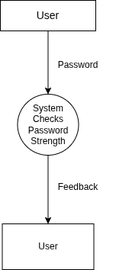
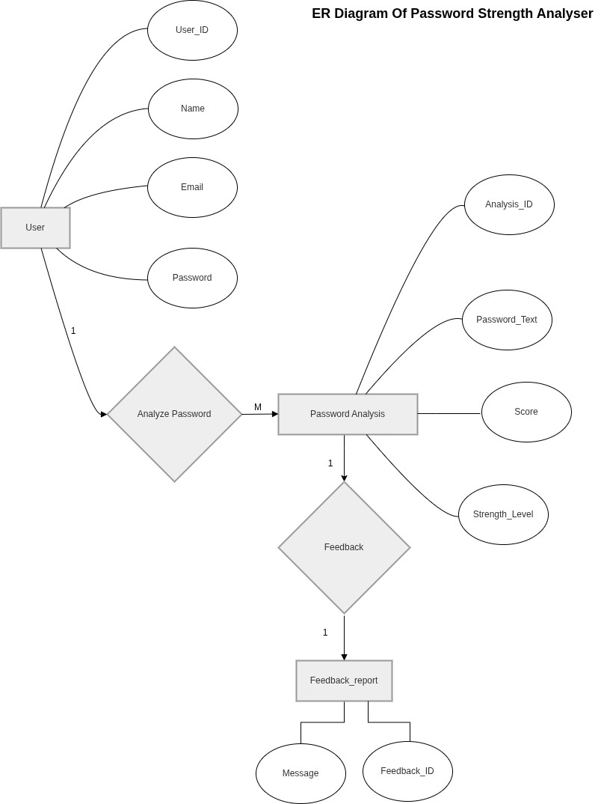

Figure 5.2 Data Flow Diagram



Figure 5.3 System Architecture Diagram
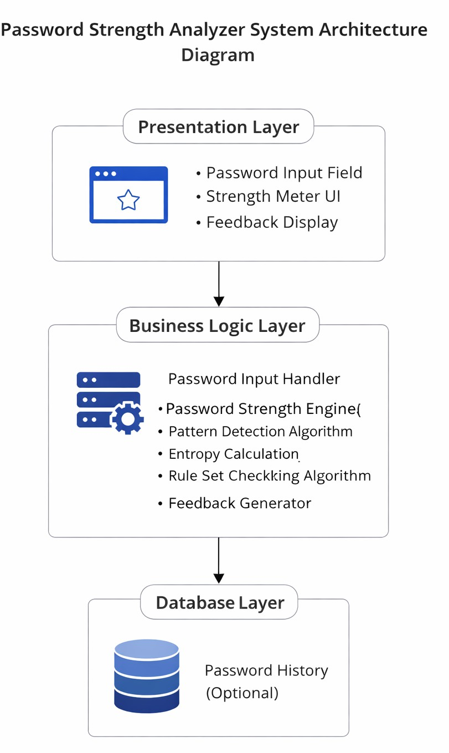

Conceptual ER diagram symbols
Conceptual Data Models establish a broad view of what should be included in the model set. Conceptual ERDs can be used as the foundation for logical data models. They may also be used to form commonality relationships between ER models as a basis for data model integration. All of the symbols

shown below are found in the UML Entity Relationship and Entity Relationship shape library of Lucidchart.

ERD entity symbols

Entities are objects or concepts that represent important data. Entities are typically nouns such as product, customer, location, or promotion. There are three types of entities commonly used in entity relationship diagrams.

Entity Symbol Name Description

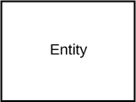
Strong entity
These shapes are independent from other entities, and are often called parent entities, since they will often have weak entities that depend on them. They will also have a primary key, distinguishing each occurrence of the entity.

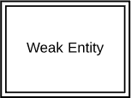
Weak entity

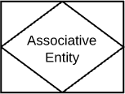
Associative entity
Weak entities depend on some other entity type. They don't have primary keys, and have no meaning in the diagram without their parent entity.

Associative entities relate the instances of several entity types. They also contain attributes specific to the relationship between those entity instances.



ERD relationship symbols

Within entity-relationship diagrams, relationships are used to document the interaction between two entities. Relationships are usually verbs such as assign, associate, or track and provide useful information that could not be discerned with just the entity types.

Relationship Symbol Name Description

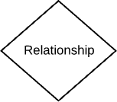
Relationship Relationships are associations
between or among entities.

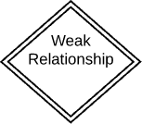
Weak relationship
Weak Relationships are connections between a weak entity and its owner.



ERD attribute symbols

ERD attributes are characteristics of the entity that help users to better understand the database. Attributes are included to include details of the various entities that are highlighted in a conceptual ER diagram.

Attribute Symbol Name Description

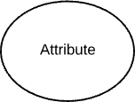
Attribute

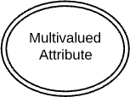
Multivalued attribute

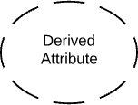
Derived attribute
Attributes are characteristics of an entity, a many-to-many relationship, or a one-to-one relationship.

Multivalued attributes are those that are can take on more than one value.

Derived attributes are attributes whose value can be calculated from related attribute values.




Relationship Relationships are associations
between or among entities.

Want to make an ERD of your own? Try Lucidchart. It's quick, easy, and completely free.
Make an ERD


Physical ER diagram symbols
The physical data model is the most granular level of entity-relationship diagrams, and represents the process of adding information to the database. Physical ER models show all table structures, including column name, column data type, column constraints, primary key, foreign key, and relationships between tables.
As shown below, tables are another way of representing entities. The key parts of Entity-relationship Tables are:

Fields

Fields represent the portion of a table that establish the attributes of the entity. Attributes are typically thought of as columns in the database that the ERD models.
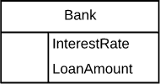
In the image above, InterestRate and LoanAmount are both attributes of the entity that are contained as fields.

Keys

Keys are one way to categorize attributes. ER diagrams help users to model their databases by using various tables that ensure that the database is organized, efficient, and fast. Keys are used to link various tables in a database to each other in the most efficient way possible.
Primary Keys
Primary keys are an attribute or combination of attributes that uniquely identifies one and only one instance of an entity.
Foreign Keys
Foreign keys are created any time an attribute relates to another entity in a one-to-one or one-to-many relationship.
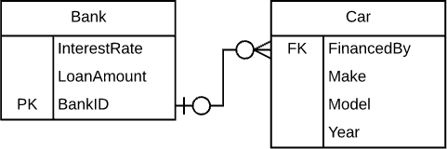


Each car can only be financed by one bank, therefore the primary key BankId from the Bank table is used as the foreign key FinancedBy in the Car table. This BankID is able to be used as the foreign key for multiple cars.

Types

Types refer to the type of data in the corresponding field in a table. Types can also refer to entity types, which describe the composition of an entity; e.g., a book's entity types are author, title, and published date.
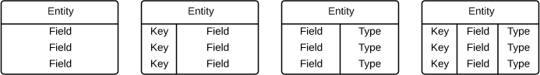

ER diagram notation
While crow's foot notation is often recognized as the most intuitive style, some use OMT, IDEF, Bachman, or UML notation, according to their preferences. Crow's foot notation, however, has an intuitive graphic format, making it the preferred ERD notation for Lucidchart. Consider using one of our Crow Foot ER Diagram templates.

Cardinality and ordinality

Cardinality refers to the maximum number of times an instance in one entity can relate to instances of another entity. Ordinality, on the other hand, is the minimum number of times an instance in one entity can be associated with an instance in the related entity.
Cardinality and ordinality are shown by the styling of a line and its endpoint, according to the chosen notation style.


Practical 6

User’s view Analysis

Aim: Perform the user's view analysis for the suggested system by drawing Use case Diagram.

User View Analysis

User’s view analysis is the process of understanding the interactions of different users with the system. It helps in identifying the functionalities required by different users and ensures that the system meets their needs effectively.

Purpose of Use-Case:
The Use case diagram is used to gather the requirements of a system. It is used to get an out side view of a system. It Identifies the external and internal factors influencing the system. It is also used to show the interaction among the requirements.

  - Notations of Use-Case:

Notation Description | Visual Representation
Actor
- Someone interacts with use case (system function).
- Named by noun.
- Actor plays a role in the business
- Similar to the concept of user, but a user can play different roles.
Use Case
System function(process-automated or manual) Named by verb+ Noun(or Noun Phrase).
Communication Link
The participation of an actor in a use case is shown by connecting an actor to a use-case by a solid link. Actors may be connected to use cases by associations, indicating that the actor and the use-case communicate


with one another using messages.

Boundary of system
- The system boundary is potentially the entire system as defined in the requirements document. For large and complex systems,
each module may be the system boundary.
Extends  - Example: Indicates that an "Invalid- QR code" use case may include the behavior specified by base use case "Login Account".  - Depict with a directed arrow having a dotted line. The tip of arrow head points to the base use case and the child use case is connected at the base of the arrow. The stereotype"<<extends>>"identifies as an extend relationship | 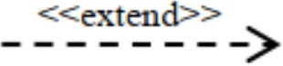
Include  - When a use case is depicted as using the functionality of another use case, the relationship between the use cases is named as include or uses relationship.  - A use case includes the functionality described in another use case as a part of its business process flow. Thestereotype"<<include>>"identifiestherela tionshipasanincluderelationship. | 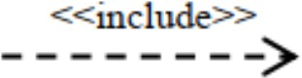
Generalization

1 A generalization relationship is a parent-child relationship between use cases.



6.3 User’s View Analysis for Library Management System
User’s view analysis is the process of understanding how different users interact with the QRCode Pro. It helps identify the functionalities required by each user type and ensures the system effectively meets their needs.

Actors in the System

An actor is an entity that interacts with the system. The QRCode Pro includes the following actors:

- General User

  - Enters QR codes to check their strength.

  - Receives real-time feedback and suggestions.

  - Improves QR code quality based on recommendations.

  - (Optional) Views previous QR code generation history.

- Security Analyst

  - Defines QR code quality rules and evaluation criteria.

  - Updates type detection logic (e.g., common QR codes, sequences).

  - Monitors effectiveness of QR generation algorithms.

  - Enhances system security measures over time.

- System Administrator

  - Oversees system operations and deployment.

  - Manages system configurations and updates.

  - Monitors system usage and performance.

  - Maintains optional user data and system logs.

Use Cases

A use case represents a specific function performed by an actor within the system.


For General Users:
    - Enter QR code – Input a QR code for analysis.
    - Check QR Code Quality – View QR code preview (weak/medium/strong).
    - View Feedback – Receive suggestions to improve QR code security.
    - Improve QR code – Modify QR code based on recommendations.
    - View Analysis History (Optional) – Check past QR code generations.
For Security Analysts:
    - Define Rules – Set criteria for QR code quality evaluation.
    - Update Pattern Library – Add or modify known weak patterns.
    - Tune Algorithms – Improve QR encodings and detection logic.
For System Administrators:

- Manage System Configuration – Configure backend settings and deployment.
- Monitor System Usage – Track system activity and performance.
- Maintain System Data – Manage optional QR code history and logs.
Figure 1: use case diagram
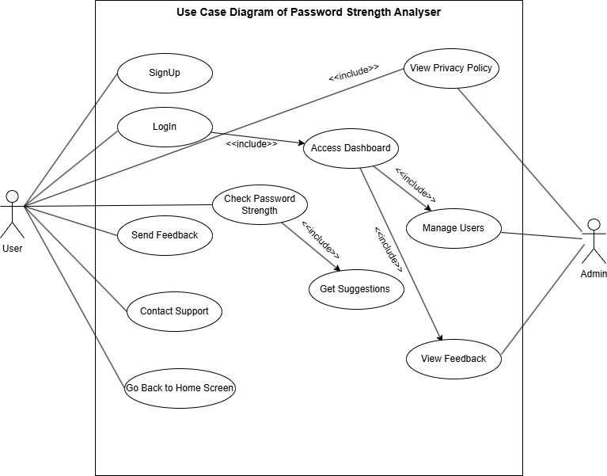

Practical 7

Structural View Diagram

Aim: To Design structural view diagram for the selected system using class Diagram, Object Diagram, and Component Diagram.

Structural View Diagrams
Structure diagrams depict the static structure of the elements in your system. i.e., how one object relates to another.It shows the things in the system – classes, objects, packages or modules, physical nodes, components, and interfaces. Since structure diagrams represent the structure, they are used extensively in documenting the software architecture of software systems. The Seven UML structural diagrams are roughly organized around the major groups of things you’ll find when modeling a system. Since structure diagrams represent the structure, they are used extensively in documenting the software architecture of software systems.

Table 7.1:Structural View Diagram

Structural Diagram Brief Description

Composite Structure Diagram
It shows the internal structure of a classifier, classifier interactions with the environment through ports, or behavior of a collaboration.


Deployment Diagram It shows a set of nodes and their relationships that
illustrates the static deployment view of an architecture.
Package Diagram It groups related UML elements into a collection of
logically related UML structure.
Class Diagram It shows a set of classes, interfaces, and collaborations
and their relationships, typically, found in modeling object-oriented systems.
Object Diagram It shows a set of objects and their relationships, which
is the static snapshots of instances of the things found in class diagrams.
Component Diagram It shows a set of components and their relationships
that illustrates the static implementation view of a system.


Class Diagram
The UML Class diagram is a graphical notation used to construct and visualize object oriented systems. A class diagram in the Unified Modeling Language (UML) is a type of static structure diagram that describes the structure of a system by showing the system's:
classes,
their attributes, operations (or methods),
and the relationships among objects.
Purpose of Class diagram:
      - Class diagram is a static diagram.
      - It represents the static view of an application.
      - Class diagram is not only used for visualizing, describing, and documenting different aspects of a system but also for constructing executable code of the software application.

Notations Class Notation
A class notation consists of three parts:

Class Name
  - The name of the class appears in the first partition.

Class Attributes
  - Attributes are shown in the second partition.
  - The attribute type is shown after the colon.
  - Attributes map onto member variables (data members) in code.
- Class Operations (Methods)
  - Operations are shown in the third partition. They are services the class provides.
  - The return type of a method is shown after the colon at the end of the method signature.
  - The return type of method parameters is shown after the colon following the parameter name.
  - Operations map onto class methods in code 3.12
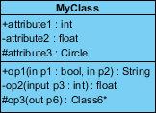

The graphical representation of the class - MyClass as shown above:
- MyClass has 3 attributes and 3 operations


- Parameter p3 of op2 is of type int
- op2 returns a float
- op3 returns a pointer (denoted by a *) to Class6

Class Relationships
A class may be involved in one or more relationships with other classes. A relationship can be one of the following types: (Refer to the figure on the right for the graphical representation of relationships).

Inheritance (or Generalization):

- Represents an "is-a" relationship.
- An abstract class name is shown in italics.
- SubClass1 and SubClass2 are specializations of Super Class.
- A solid line with a hollow arrowhead that point from the child to the parent class

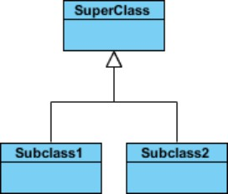

Simple Association:
  - A structural link between two peer classes.
  - There is an association between Class1 and Class2
  - A solid line connecting two classes
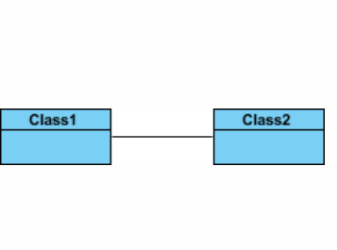



Aggregation:
A special type of association. It represents a "part of" relationship.
- Class2 is part of Class1.
- Many instances (denoted by the *) of Class2 can be associated with Class1.
- Objects of Class1 and Class2 have separate lifetimes.
- A solid line with an unfilled diamond at the association end connected to the class of composite
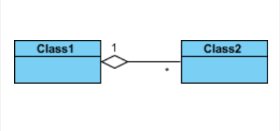

Composition:
A special type of aggregation where parts are destroyed when the whole is destroyed.
- Objects of Class2 live and die with Class1.
- Class2 cannot stand by itself.
- A solid line with a filled diamond at the association connected to the class of composite.
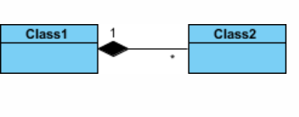

Dependency:
- Exists between two classes if the changes to the definition of one may cause changes to the other (but not the other way around).
- Class1 depends on Class2
- A dashed line with an open arrow Multiplicity
How many objects of each class take part in the relationships and multiplicity can be expressed as:
- Exactly one - 1
- Zero or one - 0..1
- Many - 0..* or *
- One or more - 1..*


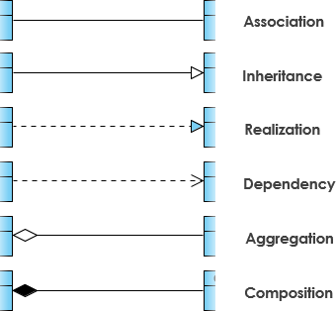

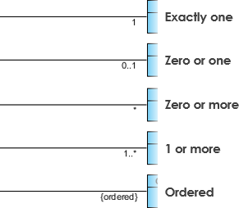


Class Diagram
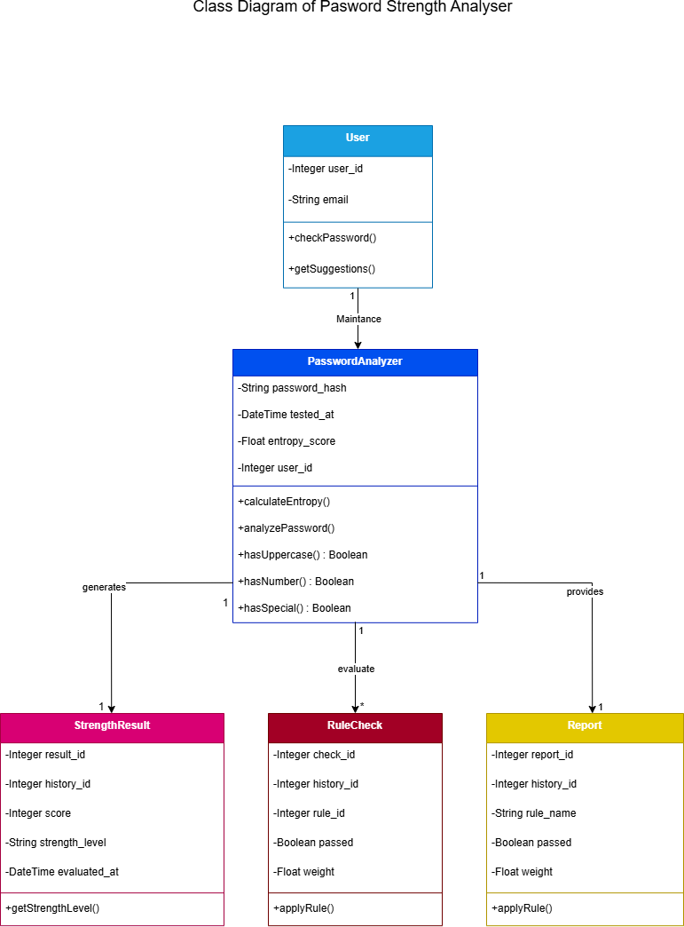
Figure 7.1 class diagram


Object Diagram
Object diagrams are a visual representation in UML (Unified Modeling Language) that illustrates the instances of classes and their relationships within a system at a specific point in time. They display objects, their attributes, and the links between them, providing a snapshot of the system’s structure during execution.

An object diagram in UML is useful because it provides a clear and visual representation of specific instances of classes and their relationships at a particular point in time, aiding in understanding and communicating the structure and interactions within a system.

Object Diagram Notations
The object diagram in UML uses specific notations to represent instances of classes and their relationships at a particular moment in time.
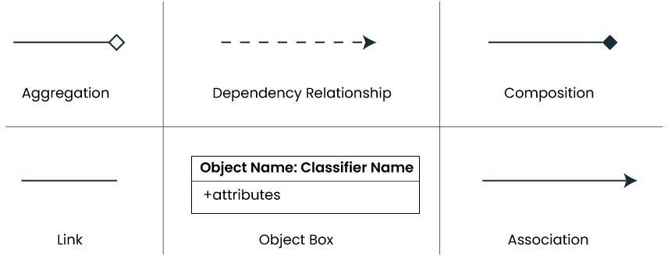

- Objects or Instance specifications
When we instantiate a classifier in a system, the object we create represents an entity which exists in the system. We can represent the changes in object over time by creating multiple instance specifications. We use a rectangle to represent an object in an object diagram

- Attributes and Values
Inside the object box, attributes of the object are listed along with their specific values.


Object Diagram

An Object diagram showing QR code generation
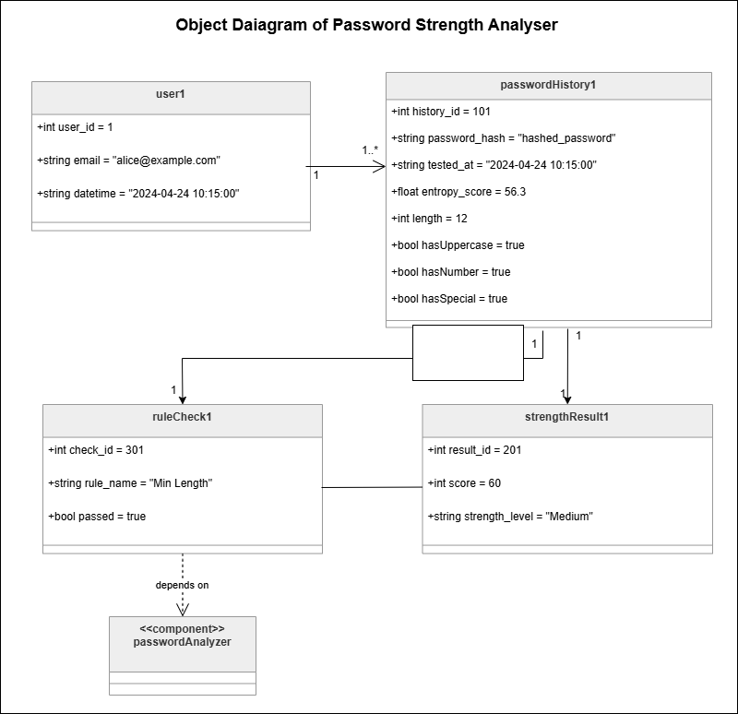

Component Diagram

Component-based diagrams are essential tools in software engineering, providing a visual representation of a system’s structure by showcasing its various components and their interactions. These diagrams simplify complex systems, making it easier for developers to design, understand, and communicate the architecture
.


Components of Component-Based Diagram

- Component
Represent modular parts of the system that encapsulate functionalities. Components can be software classes, collections of classes, or subsystems.
Symbol: Rectangles with the component stereotype («component»). Function: Define and encapsulate functionality, ensuring modularity and reusability.
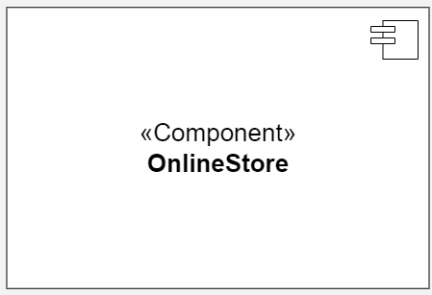

- Interfaces
Specify a set of operations that a component offers or requires, serving as a contract between the component and its environment.
Symbol: Circles (lollipops) for provided interfaces and half-circles (sockets) for required interfaces.
Function: Define how components communicate with each other, ensuring that components can be developed and maintained independent.


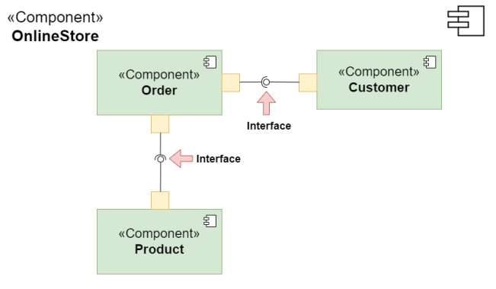



- Relationships

Depict the connections and dependencies between components and interfaces.
- Symbol: Lines and arrows.
-Dependency (dashed arrow): Indicates that one component relies on another.
-Association (solid line): Shows a more permanent relationship between components.
-Assembly connector: Connects a required interface of one component to a provided interface of another.
- Function: Visualize how components interact and depend on each other, highlighting communication paths and potential points of failure.

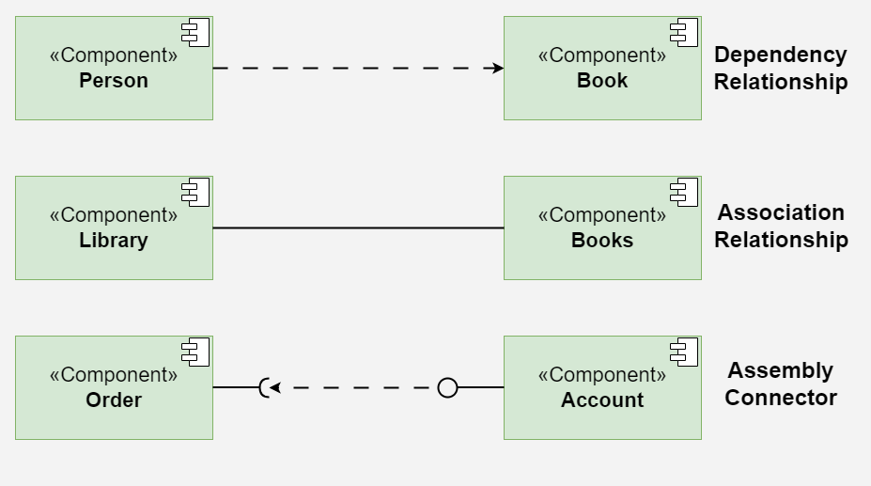

- Ports

Role: Represent specific interaction points on the boundary of a component where interfaces are provided or required.
Symbol: Small squares on the component boundary.
Function: Allow for more precise specification of interaction points, facilitating detailed design and implementation.
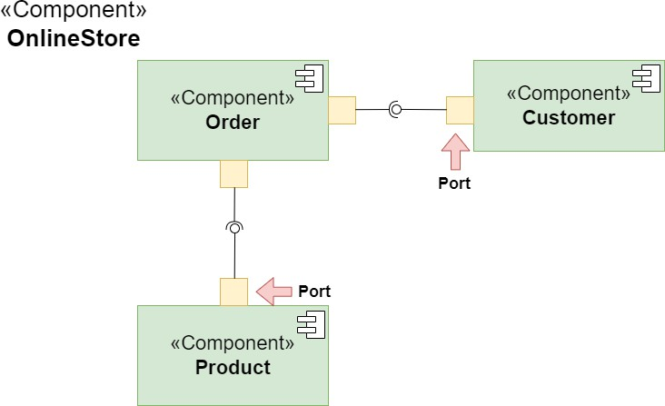



- Artifacts

Represent physical files or data that are deployed on nodes.
Symbol: Rectangles with the artifact stereotype («artifact»).
Function: Show how software artifacts, like executables or data files, relate to the components.


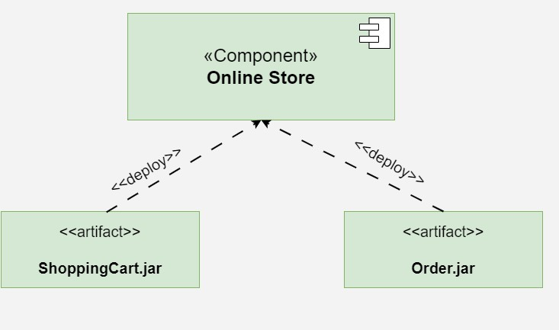

- Nodes

Represent physical or virtual execution environments where components are deployed.
Symbol: 3D boxes.
Function: Provide context for deployment, showing where components reside and execute within the system’s infrastructure.

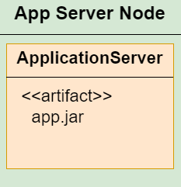

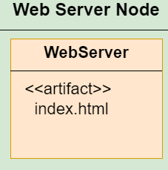



    - Component Diagram
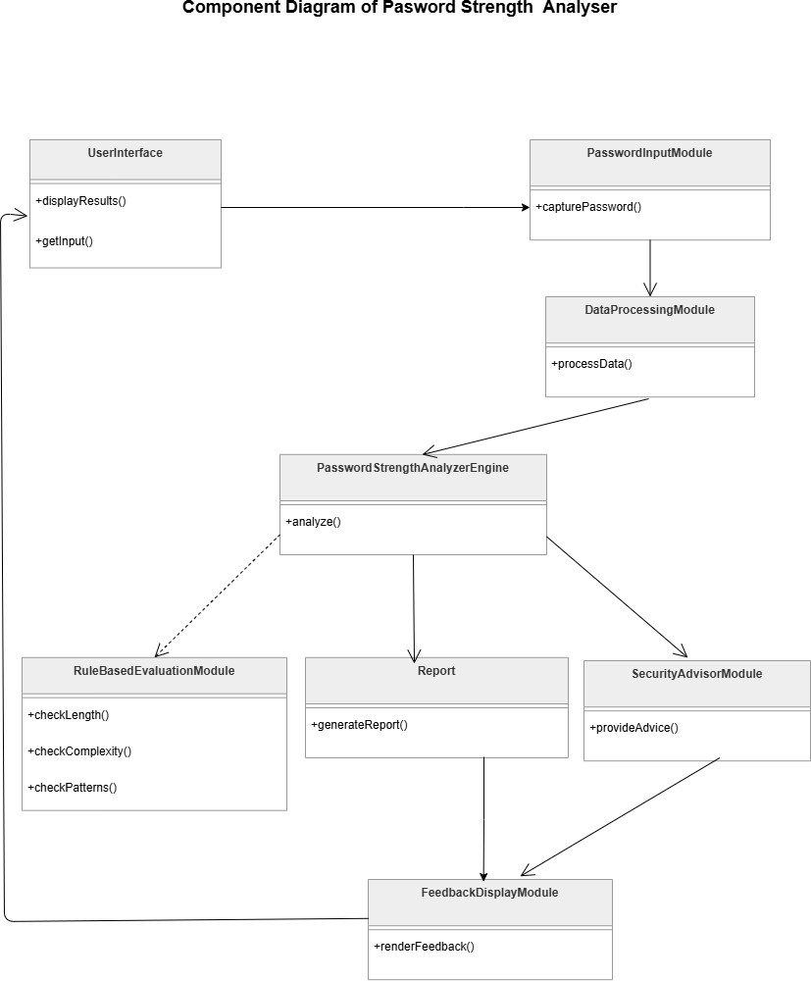



Practical 8

Function -Oriented diagram
Aim: Design function-oriented diagram for the selected system using Data Flow Diagrams

8.1 Data Flow Diagrams(DFD)

Purpose of Data Flow Diagrams:
A data flow diagram (DFD) maps out the flow of information for any processor system. It uses defined symbols like rectangles, circles and arrows, plus short text labels, to show data inputs, outputs, storage points and the routes between each destination.

Notations of Data Flow Diagrams:
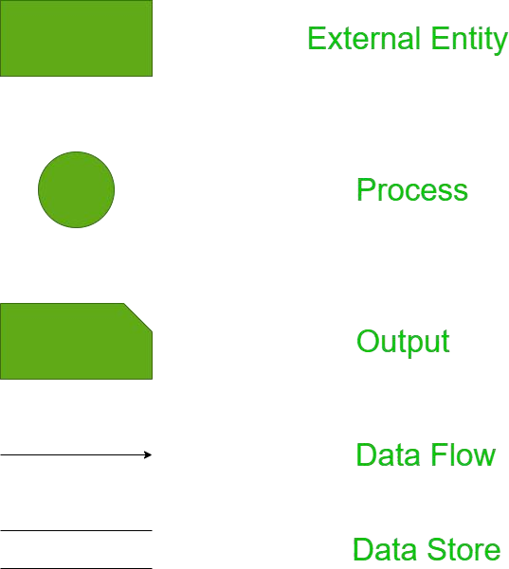



      - Entities:
        - Entities include source and destination of the data. Entities are represented by
rectangle with their corresponding names.
      - Process:
        - The tasks performed on the data is known as process. Process is represented by circle.
Somewhere round edge rectangles are also used to represent process.

      - Data Storage:
- Data storage includes the database of the system. It is represented by rectangle with both smaller sides missing or in other words within two parallel lines.
- Data Flow:
  - The movement of data in the system is known as dataflow. It is represented with the help
of arrow. The tail of the arrow is source and the head of the arrow is destination.

Levels of Data Flow Diagrams:
      - In Software engineering DFD (data flow diagram) can be drawn to represent the system of different levels of abstraction. Higher-level DFDs are partitioned into low levels-hacking more information and functional elements. Levels in DFD are numbered 0, 1, 2or beyond.
Here, we will see mainly 3 levels in the data flow diagram, which are:0-level DFD,1-level DFD, and2-levelDFD.

- 0-level DFD:
  - It is also known as a context diagram. It’s designed to be an abstraction view, showing the system as a single process with its relationship to external entities. It represents the entire system as a single bubble within put and output data indicated by incoming/outgoing arrows.

- 1-level DFD:
  - In 1-level DFD, the context diagram is decomposed into multiple bubbles/processes. In this level, we highlight the main functions of the system and breakdown thehigh- levelprocessof0-levelDFDinto sub processes.

- 2-level DFD:
  - 2-level DFD goes one step deeper into parts of 1-level DFD. It can be used to plan or record the specific/necessary detail about the system’s functioning.



DFD of QRCode Pro

Level 0(Context level diagram )
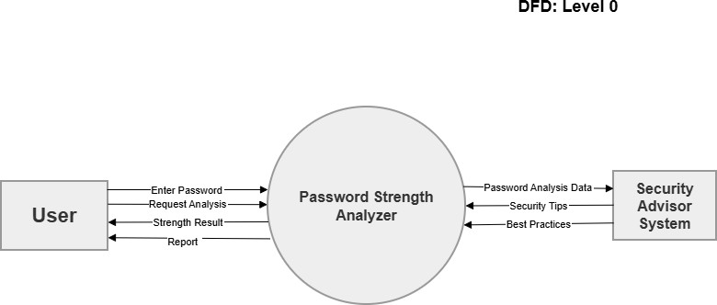

Figure 8.1 Level 0 DFD

Level 1 DFD
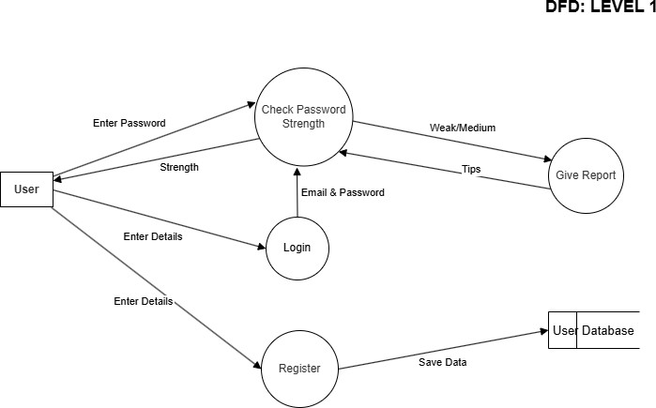


Practical 9

Behavioral View diagram

Aim: Design the behavioral view diagram for the selected system. Use following diagrams

- Interaction Diagrams a. Sequence Diagrams b. Collaboration Diagram

- State–Chart Diagrams

- Activity Diagrams

Behavioral diagrams are used to visualize, specify, construct, and document the dynamic aspects of a system. It shows how the system behaves and interacts with itself and other entities (users, other systems). They show how data moves through the system, how objects communicate with each other, how the passage of time affects the system, or what events cause the system to change internal states. Since behavior diagrams illustrate the behavior of a system, they are used extensively to describe the functionality of software systems. As an example, the activity diagram describes the business and operational step-by-step activities of the components in a system. In other words, a behavioral diagram shows how the system works ‘in motion’, that is how the system interacts with external entities and users, how it responds to input or event and what constraints it operates under.

Interaction Diagrams

The purpose of interaction diagrams is to visualize the interactive behavior of the system Sequence and collaboration diagrams are used to capture the dynamic nature but from a different angle.

Terminology of Interaction diagram:
- An interaction diagram contains lifelines, messages, operators, state invariants and constraints.
Lifeline

A lifeline represents a single participant in an interaction. It describes how an instance of a specific classifier participates in the interaction. A life line represents a role that an instance of the classifier may play in the interaction.
Various attributes of a lifeline,

Name
- It is used to refer to the life line within a specific interaction.
- The name of a life line is optional.

- Type
- It is the name of a classifier of which the life line represents an instance.
- Selector
- It is a Boolean condition which is used to select a particular instance that satisfies the requirement.
- Select or attribute is also optional.

Messages

A message is a specific type of communication between two lifelines in an interaction. A message involves following activities
A call message which is used to call an operation. A message to create an instance.
A message to destroy an instance. For sending a signal.

Message Type Description Example

Synchronous Sender waits for receiver to complete before continuing
Asynchronous Sender continues without waiting for
response
Return Represents return of control or data from
receiver to sender
objectA.method() sendMessage() return value

Create Indicates creation of a new object new Object() Delete Indicates termination of an object object.destroy() Self-Message An object sends a message to itself this.doSomething()

Found Message
Message originates outside the system or is unidentified
External API call

Lost Message Message is sent but the destination is
unknown or not modeled
Log message not saved



State in variants and constraints

- When an instance or a lifeline receives a message, it can cause it to change the state.
- A state is a condition or a situation during a life time of an object at which it satisfies some constraint, performs some operations, and waits for some event.
- In an interaction diagram, not all messages cause changes to change the state of an instance.

Some messages donot have the values of some attributes. It has no side effects on the state of an object.

Operator
An operator specifies an operation on how the operands are going to be executed.
- The operators in UML support operations on data in the form of branching as well as an iteration. Various operators can be used to ensure the use of iteration and branching in the UML model.


Iteration
    - In an interaction diagram, we can also show iteration using an iteration expression.
    - An iteration expression consists of an iteration specifier and an optional iteration clause. There is no pre-specified syntax for UML iteration.

Branching
    - In an interaction diagram, we can represent branching by adding guard conditions to the messages. Guard conditions are used to check if a message can be sent forward or not.
    - A message is sent forward only when its guard condition is true.
    - A message can have multiple guard conditions, or multiple messages can have the same guard condition.
    - Branching in UML is achieved with the help of alt and opt, operators.

Types of Interaction diagram:
  - Different types of interaction diagrams defined in UML:
  - Sequence diagram
  - Collaboration diagram
  - Timing diagram

Sequence diagram

Sequence Diagrams are interaction diagrams that detail how operations are carried out. They capture the interaction between objects in the context of a collaboration. Sequence Diagrams are time focus and they show the order of the interaction visually by using the vertical axis of the diagram to represent time what messages are sent and when.

Purpose of Sequence Diagram
- Model high-level interaction between active objects in a system
- Model the interaction between object instances within a collaboration that realizes a use case
- Model the interaction between objects within a collaboration that realizes an operation
- Either model generic interactions (showing all possible paths through the interaction) or specific instances of a interaction (showing just one path through the interaction)

Sequence Diagram Notation

Notation Symbol
Actor
- A type of role played by an entity that interacts with the subject (e.g., by exchanging signals and data)
- External to the subject (i.e., in the sense that an instance of an actor is not a part of the instance of its corresponding subject).
- Represent roles played by human users, external hardware, or other subjects.

Lifeline

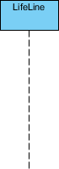
- A lifeline represents an individual participant in the Interaction.



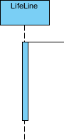
Activations
  - A thin rectangle on a lifeline) represents the period during which an element is performing
an operation.
  - The top and the bottom of the of the rectangle are aligned with the initiation and the completion
time respectively



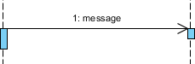
Call Message
  - A message defines a particular communication between Lifelines of an Interaction.
  - Call message is a kind of message that represents an invocation of operation of target
lifeline.

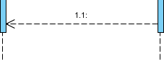
Return Message
  - A message defines a particular communication between Lifelines of an Interaction.
  - Return message is a kind of message that represents the pass of information back to the caller
of a corresponded former message.

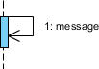
Self Message
- A message defines a particular communication between Lifelines of an Interaction.
- Self message is a kind of message that represents the invocation of message of the same lifeline.

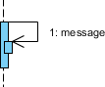
Recursive Message
- A message defines a particular communication between Lifelines of an Interaction.
- Recursive message is a kind of message that represents the invocation of message of the same
lifeline. It's target points to an activation on top of the activation where the message was invoked from.



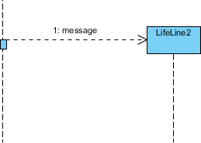
Create Message
- A message defines a particular communication between Lifelines of an Interaction.
- Create message is a kind of message that represents the instantiation of (target) lifeline.

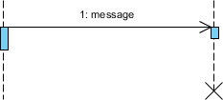
Destroy Message
  - A message defines a particular communication between Lifelines of an Interaction.
  - Destroy message is a kind of message that represents the request of destroying the lifecycle of target lifeline.

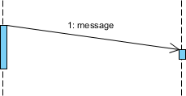
Duration Message
  - A message defines a particular communication between Lifelines of an Interaction.
  - Duration message shows the distance between two time instants for a message invocation.


Note
A note (comment) gives the ability to attach various remarks to elements. A comment carries no semantic force, but may contain information that is useful to a modeler.

Message and Focus of Control
- An Event is any point in an interaction where something occurs.
- Focus of control: also called execution occurrence, an execution occurrence
- It shows as tall, thin rectangle on a lifeline)
- It represents the period during which an element is performing an operation. The top and the bottom of the rectangle are aligned with the initiation and the completion time respectively.



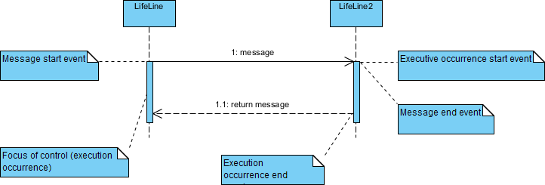

Sequence Fragments
  - Sequence fragments make it easier to create and maintain accurate sequence diagrams
  - A sequence fragment is represented as a box, called a combined fragment, which encloses a portion of the interactions within a sequence diagram
  - The fragment operator (in the top left cornet) indicates the type of fragment
  - Fragment types: ref, assert, loop, break, alt, opt, neg

Operator Fragment Type
alt Alternative multiple fragments: only the one whose condition is true will execute.
opt Optional: the fragment executes only if the supplied condition is true. Equivalent to an alt only with one trace.
par Parallel: each fragment is run in parallel.
loop Loop: the fragment may execute multiple times, and the guard indicates the basis of iteration.
region Critical region: the fragment can have only one thread executing it at once.
neg Negative: the fragment shows an invalid interaction.
ref Reference: refers to an interaction defined on another diagram. The frame is drawn to cover the lifelines involved in the interaction. You can define parameters and a return value.
sd Sequence diagram: used to surround an entire sequence diagram.

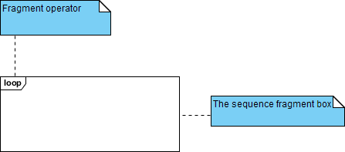



Collaboration Diagram (Communication diagram)

Collaboration diagrams (known as Communication Diagram) are used to show how objects interact to perform the behavior of a particular use case, or a part of a use case. Along with sequence diagrams, collaboration are used by designers to define and clarify the roles of the objects that perform a particular flow of events of a use case. They are the primary source of information used to determining class responsibilities and interfaces.

      - A Collaboration is a collection of named objects and actors with links connecting them. They collaborate in performing some task.
      - A Collaboration defines a set of participants and relationships that are meaningful for a given set of purposes
      - A Collaboration between objects working together provides emergent desirable functionalities in Object-Oriented systems
      - Each object (responsibility) partially supports emergent functionalities
      - Objects are able to produce (usable) high-level functionalities by working together
      - Objects collaborate by communicating (passing messages) with one another in order to work together
Notations of Collaboration Diagram

Objects
An object is represented by an object symbol showing the name of the object and its class underlined, separated by a colon:
Object_name : class_name
You can use objects in collaboration diagrams in the following ways:
- Each object in the collaboration is named and has its class specified
- Not all classes need to appear
- There may be more than one object of a class
- An object’s class can be unspecified. Normally you create a collaboration diagram with objects first and specify their classes later.
- The objects can be unnamed, but you should name them if you want to discriminate different objects of the same class.

Actors
Normally an actor instance occurs in the collaboration diagram, as the invoker of the interaction. If you have several actor instances in the same diagram, try keeping them in the periphery of the diagram.
- Each Actor is named and has a role
- One actor will be the initiator of the use case

Links
Links connect objects and actors and are instances of associations and each link corresponds to an association in the class diagram
Links are defined as follows:
- A link is a relationship among objects across which messages can be sent. In collaboration diagrams, a link is shown as a solid line between two objects.
- An object interacts with, or navigates to, other objects through its links to these objects.


- A link can be an instance of an association, or it can be anonymous, meaning that its association is unspecified.
- Message flows are attached to links, see Messages.

Messages
A message is a communication between objects that conveys information with the expectation that activity will ensue. In collaboration diagrams, a message is shown as a labeled arrow placed near a link.
- The message is directed from sender to receiver
- The receiver must understand the message
- The association must be navigable in that direction

Steps for Creating Collaboration Diagrams

- Identify behavior whose realization and implementation is specified
- Identify the structural elements (class roles, objects, subsystems) necessary to carry out the functionality of the collaboration
  - Decide on the context of interaction: system, subsystem, use case and operation
- Model structural relationships between those elements to produce a diagram showing the
context of the interaction
- Consider the alternative scenarios that may be required
  - Draw instance level collaboration diagrams, if required.
  - Optionally draw a specification level collaboration diagram to summarize the alternative scenarios in the instance level sequence diagrams



State–Chart Diagrams

Purpose of State-Chart diagram:

State-chart diagram describes the flow of control from one state to another state. States are defined as a condition in which an object exists and it changes when some event is triggered. The most important purpose of State-chart diagram is to model lifetime of an object from creation to termination.

Notations of State-Chart diagram:

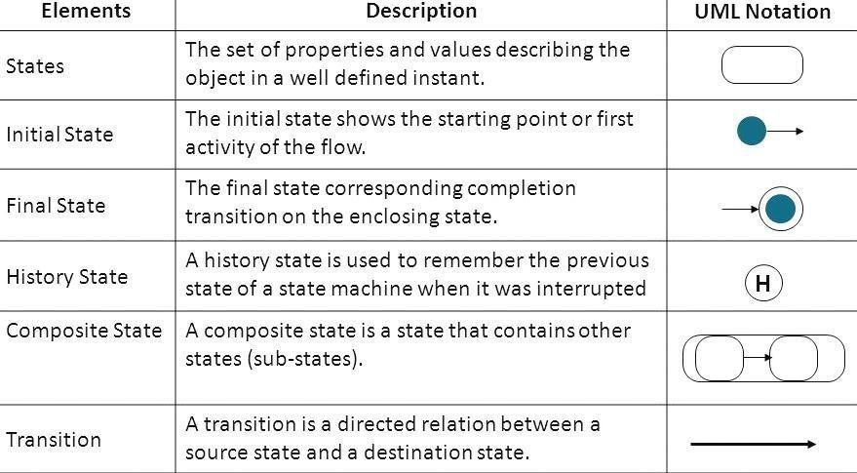



Activity Diagram

Purpose of Activity Diagram:
An activity diagram shows business and software processes as a progression of actions. These actions can be carried out by people, software components or computers. Activity diagrams are used to describe business processes and use cases as well as to document the implementation of system processes.

Notations of Activity Diagram:

Notation Description | Visual Representation
Initial State or Start Point  - A small filled circle followed by an arrow represents the initial action state or the start point for any activity diagram. | 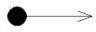
Activity or Action State  - Anactionstaterepresentsthenon- interruptibleactionofobjects.Youcandrawanactionstateu singarectanglewith rounded corners. | 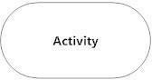
Action Flow
- It Action flows, also called edges and paths, illustrate the transitions from one action state to another. They are usually drawn with an arrowed line.
Object Flow  - Object flow refers to the creation and modification of objects by activities. An object flow arrow from anactiontoanobjectmeansthattheactioncreatesorinfluenc estheobject. | 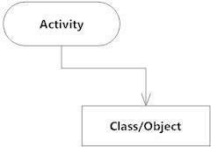
Decisions and Branching  - A diamond represents a decision with alternate paths. When an activity requires a decision prior to moving on to the next activity, add a diamond between the two activities. | 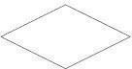



Synchronization  - A join node joins multiple concurrent flows back into a single outgoing flow.  - A fork and join mode used together are often referred to as synchronization. | 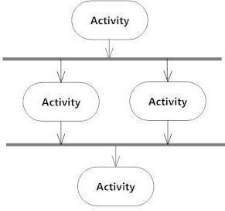
Time Event  - This refers to an event that stops the flow for a time; an hour glass depicts it. | 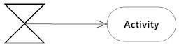
Merge Event  - A merge event brings together multiple flows that are not concurrent. | 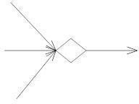
Sent and Received Signals  9 They appear in pairs of sent and received signals, because the state can't change until a response is received. | 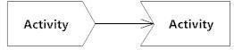
Interrupting Edge  - They An event, such as a cancellation, that interrupts the flow denoted with a lightning bolt. | 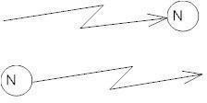



Fig 1 Sequence Diagram of QRCode Pro
Fig 2 Collaboration Diagram for QRCode Pro


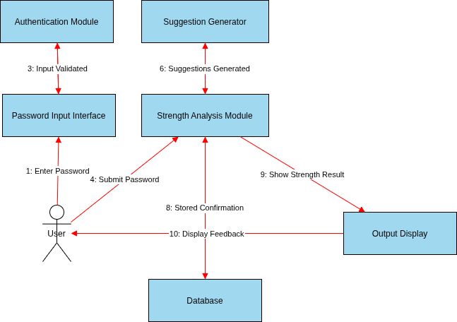

Fig 3 State Chart Diagram for QRCode Pro


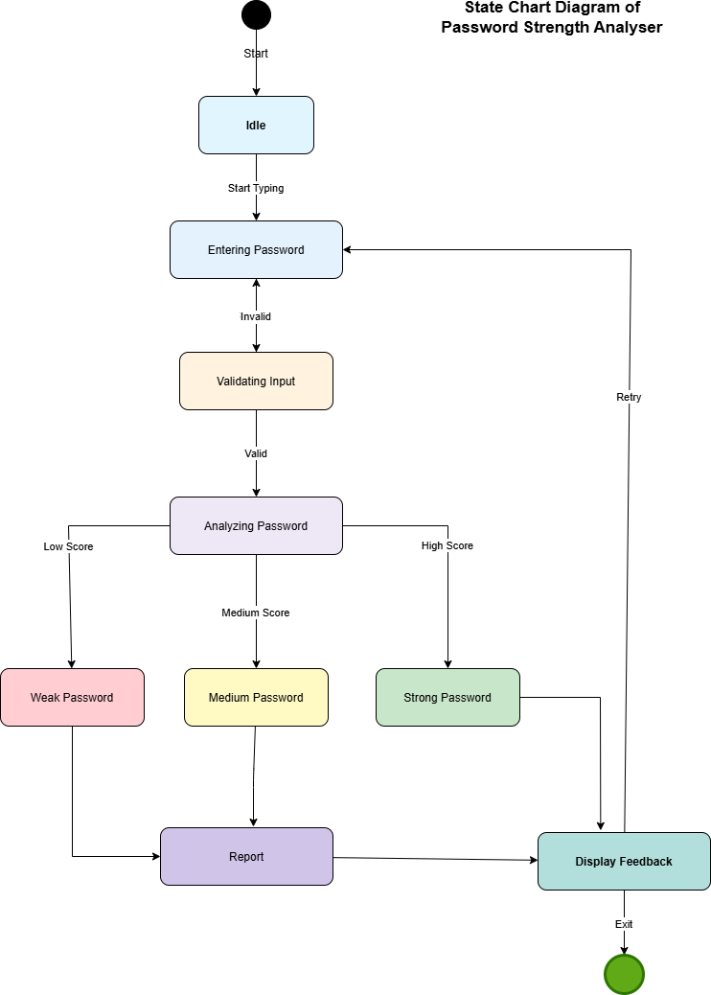

Fig 4 Activity Diagram QRCode Pro
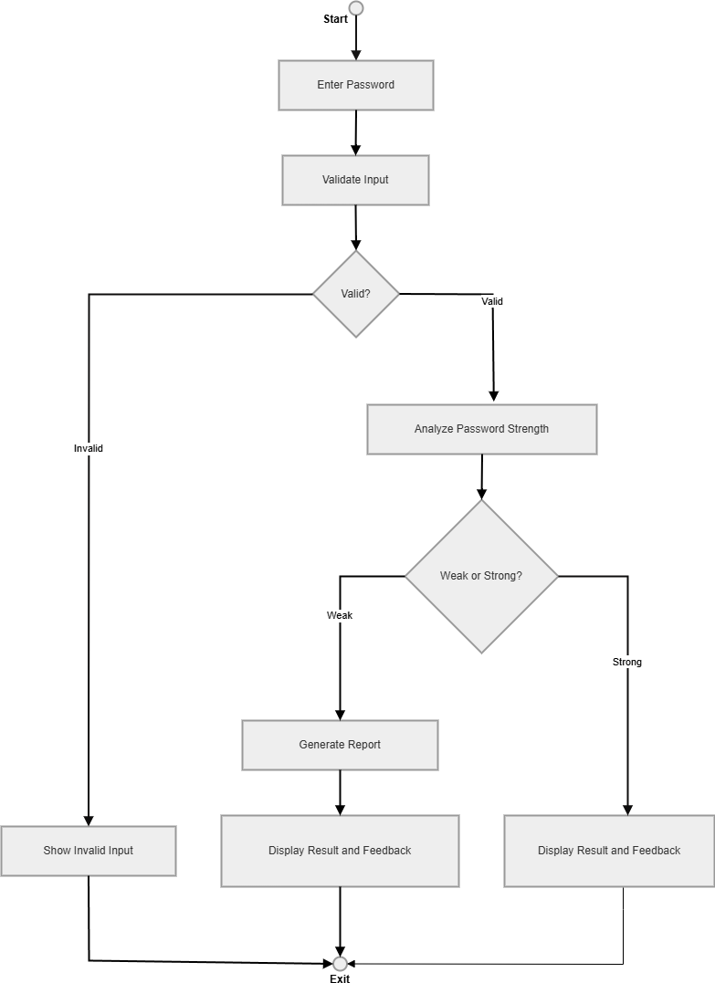


Practical 10
(Development and Management of Software using Reverse Engineering)

Step 1: Existing Solution and URL

Software: QR Monkey (Free QR Code Generator)
URL: https://www.qrmonkey.com

Step 2: Existing Features with Details
- Generate QR codes for URL, text, email, phone, SMS, WiFi, vCard
- Basic color customization (foreground + background)
- Logo upload in center of QR code
- Download as PNG or SVG
- No user accounts required
- Mobile-responsive web interface

Step 3: Technology Used for Existing Solution
- Web-based SPA (JavaScript)
- Client-side QR generation (Canvas API)
- No backend database (stateless)
- CDN-hosted static assets
- No server-side processing for QR generation

Step 4: Reasons to Perform Reverse Engineering
- Understand how client-side QR generation works with canvas APIs
- Identify limitations in customization (only basic colors, no dot styles)
- Analyze the lack of user history, analytics, and bulk generation
- Study the stateless architecture and its privacy implications
- Build a more comprehensive solution based on identified gaps

Step 5: Drawbacks of Existing Solution
- Limited to ~8 QR types (no UPI, crypto, social media, calendar)
- No dot style, eye frame, gradient, or shadow customization
- No bulk generation capability
- No QR scanner integration
- No user accounts, history, or favorites
- No dashboard or analytics



Step 6: Features to be Added / Updated / Replaced / Removed

Added
- Added: 24+ QR types, 62 customization controls, bulk generation, QR scanner
- Added: User accounts with history, favorites, and dashboard analytics
- Added: Dark mode, PDF export, print, clipboard copy
Updated
- Updated: Basic colors → Full gradient support with angle control
- Updated: Logo upload → Logo with size, margin, opacity, hide-dots controls
- Updated: Single QR → Bulk generation (100 codes, CSV, ZIP)
Replaced
- Replaced: Stateless architecture → PHP + SQLite with persistent user data
- Replaced: Basic Canvas QR → qr-code-styling library with advanced rendering
Removed
- Removed: Ads and tracking (QRCode Pro is ad-free and self-hosted)
- Removed: External data dependencies

Step 7: Technologies to be Used
- Frontend: Tailwind CSS (CDN), Vanilla JavaScript
- Backend: PHP 8.0+ with PDO
- Database: SQLite (zero-config, WAL mode)
- QR Engine: qr-code-styling (client-side)
- Scanner: html5-qrcode library
- Export: jsPDF, JSZip, FileSaver.js, Chart.js

Step 8: Advantages of Updated Solution
- 24+ QR types vs ~8 in existing tool
- 62 customization controls vs basic colors only
- Persistent history with search, filter, favorites
- Bulk generation with ZIP download
- Integrated QR scanner (camera + upload)
- Self-hosted, open-source, privacy-respecting

Step 9: Blueprint of Updated Solution (Wireframe)
- Main Screens:
- Login Page
- Dashboard (summary of business)
- Accounts Page (QR codes, entries)
- Inventory Page
- Reports Page
- Settings



- Flow:
Login → Dashboard → Select Module → Perform Action → Save → Auto Sync

Step 10: Comparison

Feature | Existing (QR Monkey) | Updated Solution
QR Types | ~8 types | 24+ types (URL, WiFi, vCard, UPI, crypto, social)
Customization | Basic colors + logo | 62 controls (dots, gradients, eye frames, shadows, frames)
Bulk Generation | Not available | Up to 100 codes, CSV upload, ZIP download
QR Scanner | Not available | Camera + image upload with auto-detect
User Accounts | None | Full auth with bcrypt, sessions, profiles
History & Analytics | None | Paginated history, favorites, Chart.js dashboard



Practical 11
(Development and management of software using Forward Engineering)

Step 1: Existing Solution and URL

Software: GoQR.me (QR Code API & Generator)
URL: https://goqr.me

Step 2: Existing Features with Details
- Basic QR code generation for URL, text, phone, SMS, vCard
- Simple color customization
- REST API for QR generation (developer-focused)
- Download as PNG, SVG, EPS
- No user accounts
- Minimal UI with limited interactivity

Step 3: Technology Used for Existing Solution
- Server-side QR generation (Java backend)
- REST API architecture
- Static HTML/CSS frontend
- No client-side rendering
- No database for user data

Step 4: Drawbacks of Existing Solution
- Very limited QR types (no UPI, crypto, social media)
- No visual customization (no dot styles, gradients, logos)
- No user accounts or history management
- No bulk generation capability

- No QR scanner, outdated UI

Step 5: How to Execute Forward Engineering (Methodology, Approach, Life Cycle) Methodology:
- Agile Development (incremental improvements)

Approach:

- Requirement Analysis (understand business needs)

- System Design (architecture planning)

- Development (modular coding)

- Testing (unit + integration testing)

- Deployment (cloud + app release)

- Maintenance (updates and bug fixes)

Life Cycle:

Requirement → Design → Development → Testing → Deployment → Maintenance

Step 6: Features to be Added
  - 24+ QR types with type-specific forms
  - 62 visual customization controls across 9 categories
  - User authentication with bcrypt and session security
  - Persistent history with search, filter, favorites, CSV export
  - Bulk generation (100 codes, CSV, ZIP download)
  - Integrated QR scanner (camera + upload)
  - Dashboard with Chart.js analytics, dark mode



Step 7: Technologies to be Used
  - Frontend: Tailwind CSS (CDN), JavaScript (qr-code-styling, Chart.js, html5-qrcode)
  - Backend: PHP 8.0+ with PDO
  - Database: SQLite (zero-config, WAL mode)
  - Export: jsPDF, JSZip, FileSaver.js
  - Security: bcrypt, session regeneration, .htaccess directory blocking
  - Routing: Clean URLs via .htaccess (Apache) and router.php (dev server)

Step 8: Advantages of Updated Solution
  - Comprehensive feature set in a single, unified application
  - Self-hosted and open-source (complete data ownership)
  - Zero-configuration deployment (no npm, no build step)
  - Modern, responsive UI with dark mode and mobile bottom nav
  - Extensible architecture (add new QR types in 2 code locations)
  - 62 customization controls for professional-grade QR codes

Step 9: Blueprint of New Solution (Wireframe) Main Structure:
  - Login / Signup
  - Dashboard (business overview)
  - Sales / Billing Section
  - Inventory Section
  - Reports & Analytics
  - User Management
  - Settings



Layout Idea:
  - Left sidebar (navigation)
  - Top bar (search + profile)
  - Main content area (dynamic data)

Flow:
Login → Dashboard → Select Feature → Perform Action → Auto Save → Sync

Step 10: Comparison

Feature | Existing (GoQR.me) | New Solution
QR Types | 5 basic types | 24+ types with type-specific forms
Customization | Basic colors | 62 controls across 9 categories
Architecture | Server-side Java API | Client-side JS + PHP 8.0+ backend
User Accounts | None | Full authentication with session security
History | None | Persistent, searchable, filterable, favorites
Export Formats | PNG, SVG, EPS | PNG, SVG, PDF, Print, Clipboard copy



Practical 12

(Development and Management of Software using Re-Engineering) Step 1: Existing Solution and URL
Software: QRCode.js (Basic JavaScript QR Library)
URL: https://davidshimjs.github.io/qrcodejs/

Step 2: Existing Features with Details
  - Generate QR codes from text/URL input
  - Basic size configuration
  - Foreground and background color options
  - Canvas and SVG rendering modes
  - Lightweight JavaScript library (~15KB)

Step 3: Technology Used for Existing Solution
  - Pure JavaScript library (no framework)
  - HTML5 Canvas API
  - No backend or database
  - Client-side only

Step 4: Reasons to Perform Re-Engineering
  - Core QR rendering is functional but lacks modern features
  - No dot style or eye frame customization available
  - No gradient, logo, shadow, or frame support
  - No application wrapper (just a library)
  - Need to preserve the fast, client-side rendering approach



Step 5: Drawbacks of Existing Solution
  - Only generates basic square QR codes
  - No dot style variety (squares only)
  - No gradient or multi-color support
  - No logo/watermark overlay capability
  - No frame, label, or shadow effects
  - No application UI — just a JavaScript library

Step 6: Things Considered from Existing Solutions
  - Client-side rendering approach (fast, no server round-trip)
  - Canvas-based output (for PNG export)
  - Lightweight architecture
  - Simple CDN integration
(These should be preserved)

Step 7: Features to be Added / Updated / Replaced / Removed Added
  - Added: 6 dot styles + gradient support for all elements
  - Added: Logo overlay with size, margin, opacity, hide-dots controls
  - Added: Frame & label system, shadow effects
  - Added: Full web app with auth, history, dashboard, bulk, scanner

Updated
  - Updated: QRCode.js (basic) → qr-code-styling (advanced rendering)

  - Updated: Simple text input → 23 type-specific forms with validation

Replaced
  - Replaced: No backend → PHP 8.0+ with SQLite for persistence

Removed
  - Removed: Nothing fundamental — QRCode.js still used for simple previews

Step 8: Technologies to be Used
  - Frontend: Tailwind CSS (CDN), qr-code-styling, QRCode.js, Chart.js
  - Backend: PHP 8.0+ with PDO
  - Database: SQLite with WAL mode
  - Export: jsPDF (PDF), JSZip (bulk), FileSaver.js

Step 9: Advantages of Updated Solution
  - Full application vs just a library
  - 62 customization controls for professional QR codes
  - Persistent user data with history and analytics
  - Bulk generation and scanning capabilities
  - Modern, responsive UI with dark mode

Still maintains fast, client-side rendering approach
  - Top bar (File, Edit, View)
  - Tab section (multiple files open)
  - Text editor area
  - Status bar (line, column info)

Flow:
Open App → Create/Open File → Edit → Auto Save → Sync (optional)



Step 11: Comparison

Feature | Existing (QRCode.js) | Re-Engineered Solution
Type | JavaScript library only | Full web application with 13 routes
QR Types | Text/URL only | 24+ types with 23 input forms
Customization | Size + 2 colors | 62 controls in 9 accordion sections
Dot Styles | Square only | 6 styles + gradient support
User System | N/A (library) | Full auth, profiles, history, dashboard
Scanning | N/A | Camera + upload with auto-detect

